



**Past Highlights**

TABLE OF CONTENTS

* A. Renewable Energy and Sustainability
* B. Power Electronics and Smart Grids
* C. Advanced Combustion and Energy Conversion Technologies
* D. Energy Storage and Conversion Technologies

## Renewable Energy and Sustainability

### SOLAR POWER FORECASTING USING MACHINE LEARNING

The increasing prevalence of renewable energy in the electric energy grid has highlighted the need for accurate forecasting to facilitate effective power system planning, management, and operations. However, the intermittent and variable nature of renewable energy data makes this a challenging task. To enhance the reliability of renewable energy forecasts the Long Short-Term Memory (LSTM) model has gained attention as a potential machine learning technique that can identify nonlinear characteristics and high-level invariant structures in data. 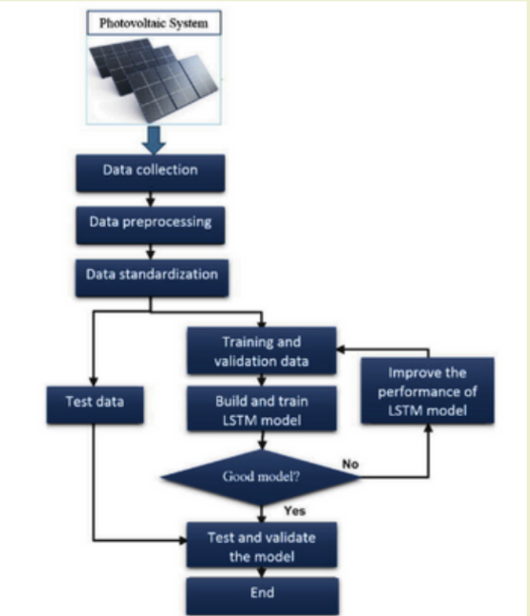

This study aimed to forecast solar irradiance using both Random Forest and LSTM networks, with LSTM demonstrating superior accuracy in terms of Mean Squared Error (MSE) and r2_score. Furthermore, the study also explored the direct forecasting of solar power using Machine Learning models such as Random Forest and Gradient Boosting Regressing models.

However, Solar energy depends heavily on local weather conditions, and as a result, typically hundreds of models are built, which need site and season specific training. The model maintenance and management also become a tedious job with such a large number of models. Therefore, this study proposes to generalize solar power forecasting models using a Bi-LSTM model and transfer-learning technique, a novel approach that has yet to be explored in the literature.

### MACHINE LEARNING BASED SOLAR PV OUTPUT PROJECTIONS USING CLIMATE MODELS

Solar energy is one of the most widely and easily available renewable source of energy. The global share of solar energy by the end of 2021 was 849 GW with an annual growth of about 133 GW. There is a need for accurate technical and economic analysis before setting up a solar power plant. 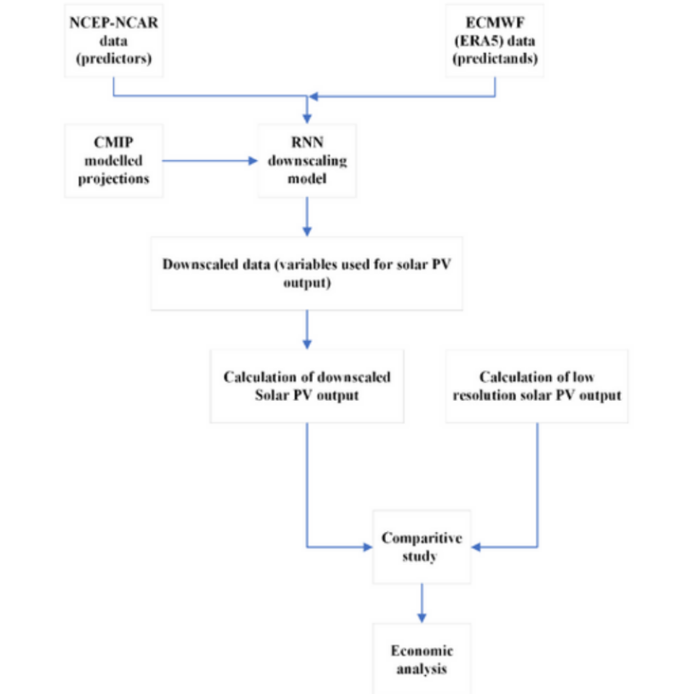

The main component of the analysis is the future projections of downscaled solar PV output using affecting parameters.

Block Diagram for downscaling of solar PV

output

The PV output is affected by a number of parameters out of which solar irradiance, temperature, relative humidity and aerosol will be taken in consideration. These parameters are forecasted by Global Climate Models (GCM) under CMIP (coupled modelled intercomparison project) at a higher resolution. The given parameters will be obtained at a lower resolution (downscaling) using machine learning techniques. This study focuses on validation of historical CMIP6 model simulations and NCEP reanalysis data with respect to ERA5 data. Historical seasonal and yearly trends have been analysed using ERA5 ECMWF data for the selected location. The area under study is (23-26) °N and (80-83) °E located in Madhya Pradesh. The time series data is used for building a downscaling model using RNN technique and obtained results are used for downscaled forecasting PV output. A further economic analysis using the results will be carried out.

### RECEIVER FOR SOLAR BAKERY

The transition of the energy sector from fossil fuel to renewables will play a key role in meeting those commitments. Offshore wind energy is proving to be a major contributor to the energy sector with 21.1 GW of offshore wind energy connected to the grid in 2021. Global climate change projected by the global climate models (GCM) under the coupled model inter-comparison project (CMIP) has been studied to project the impact of climate change on wind resources. In this study, the simulation ability of 12 CMIP6 GCMs was validated. Multi-model ensemble technique was found to be better than the individual models. The outputs from the GCMs have a coarse spatial resolution (100-300 km) which needs to be downscaled to a higher resolution to include local climate effects. The deep learning-based recurrent neural network is found to be an effective downscaling method with an improvement in the range of 6% to 18% in the PCC in recent studies. This project aims to project the high-resolution offshore wind resources at Lakshadweep Island using CMIP6 GCM wind speed as an output till 2040. The projection of offshore wind resources would provide the basis for policy-making, system planning and self-sustainability targets in the energy sector.

### FUTURE PROJECTIONS OF OFFSHORE WIND RESOURCES IN LAKSHADWEEP USING CMIP6 SIMULATIONS

The transition of the energy sector from fossil fuel to renewables will play a key role in meeting those commitments. Offshore wind energy is proving to be a major contributor to the energy sector with 21.1 GW of offshore wind energy connected to the grid in 2021. Global climate change projected by the global climate models (GCM) under the coupled model inter-comparison project (CMIP) has been studied to project the impact of climate change on wind resources. In this study, the simulation ability of 12 CMIP6 GCMs was validated. Multi-model ensemble technique was found to be better than the individual models. The outputs from the GCMs have a coarse spatial resolution (100-300 km) which needs to be downscaled to a higher resolution to include local climate effects. The deep learning-based recurrent neural network is found to be an effective downscaling method with an improvement in the range of 6% to 18% in the PCC in recent studies. This project aims to project the high-resolution offshore wind resources at Lakshadweep Island using CMIP6 GCM wind speed as an output till 2040. Projection of offshore wind resources would provide the basis for policy-making, system planning and self-sustainability targets in the energy sector.

### ENERGY EFFICIENT BATTERY THERMAL MANAGEMENT SYSTEM

The Lithium-ion batteries have become the ideal choice for a wide variety of applications including Electric Vehicles (EV) , portable hand tools, mobile phones all due to their superior energy density as well as relatively longer life span compared to otherbattery technologies. 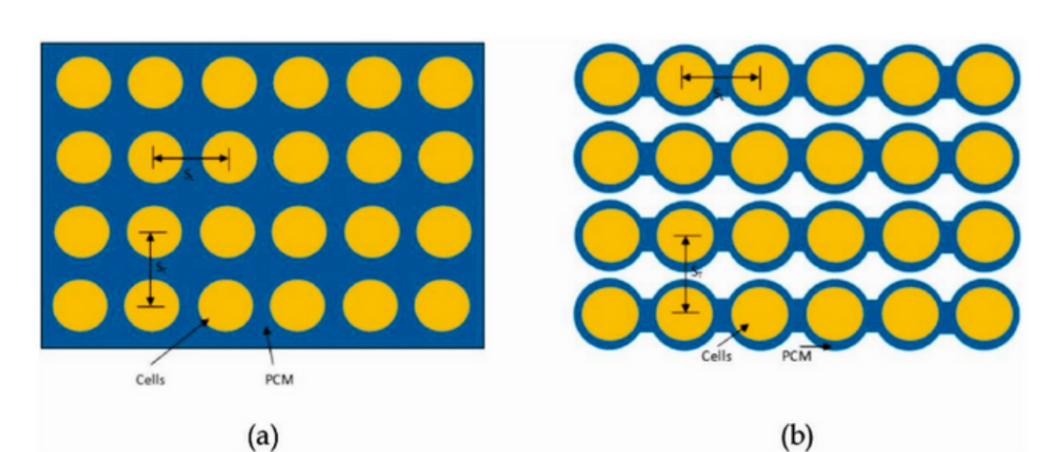

(a)Standard PCM and

(b) Hybrid BTMS (PCM & Air Cooled)

However, they have a tendency to easily overheat when charging or discharging at higher current rating. In many other battery types, it may be possible to use them without a BTMS, but it is highly dangerous to use lithium-ion batteries without any thermal management system. This report will take a look at the inner workings of a lithium-ion battery and then take a look at the conditions that cause the thermal runaway phenomenon and most of the critical thermal issues in the lithium-ion batteries. A brief discussion of some of the existing BTMS types will be reviewed.

### DECARBONISATION OF CEMENT INDUSTRY IN NEPAL

Cement Industries are the second largest emitter of anthropogenic carbon emissions after power sector. It contributes around 6 – 8 % of carbon dioxide emissions globally. Sources of carbon emissions in a cement industry are fuel combustion, calcination of limestone and indirect emissions from fossil fuel-based sources of electricity. Nepal’s cement sector is growing at a fast pace with annual production capacity of 13 million tonnes. 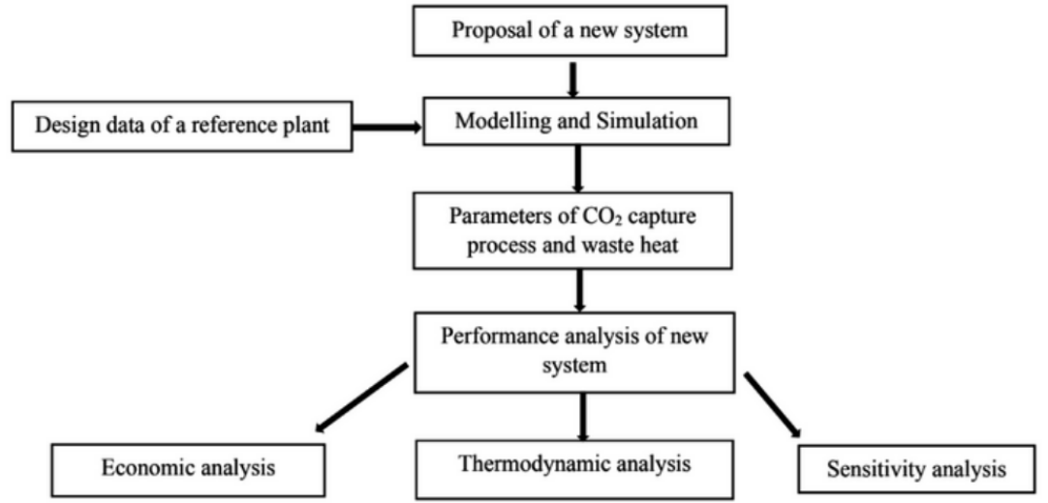

Block Diagram explaining the methodology of analysis

Given that Nepal has pledged net zero by 2045, this study is of importance. A cement industry with production capacity of 3000 tonnes per day of clinker is studied and three decarbonisation pathways for removal of CO2 from flue gas has been proposed. Modelling and simulation of these three pathways have been carried out. Also, the thermodynamic, economic and sensitivity analysis has been performed. The pathways are compared with respect to indicators like specific primary energy consumption for carbon avoidance and cost of carbon avoidance. The methodology used for the analysis has been explained with a block diagram below.

### CO-GASIFICATION OF SANITARY NAPKIN WITH SAWDUST BIOMASS IN DOWNDRAFT GASIFIER FOR THERMAL APPLICATIONS: AN EXPERIMENTAL APPROACH

Co-gasification is considered an effective treatment method for waste containing plastics and biomass for conversion into producer gas. 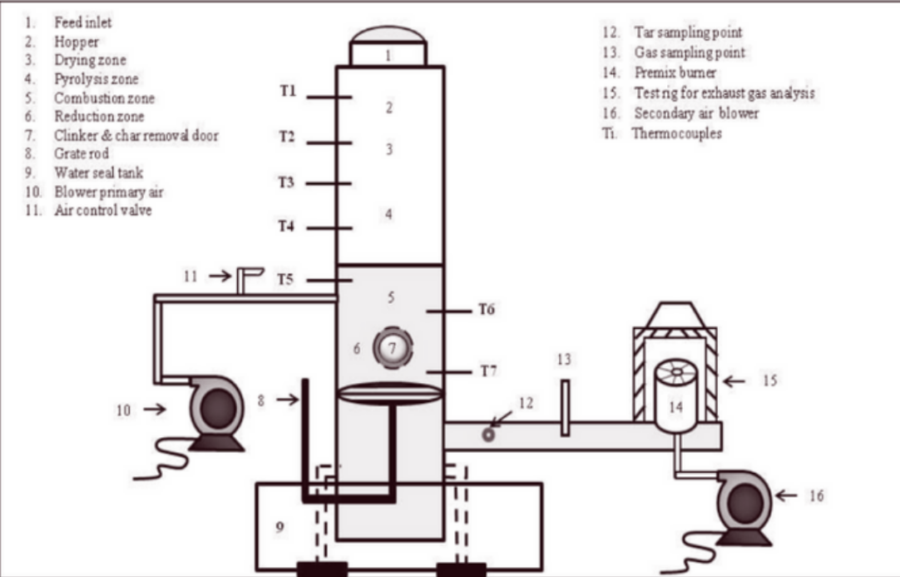

Process Diagram

This paper investigates treasting personal hygiene care products like sanitary napkin waste by co-gasification with sawdust biomass pellets in a 50KWh capacity downdraft gasifier to generate producer gas for thermal applications. The present experimental study is one of its kind for treating sanitary napkins waste via co-gasification technology that focuses on energy generation. Water loaded sanitary napkin content was increased from 0 wt.% to 3.8 wt.% in the total feedstock to evaluate the producer gas quality. Moisture plays dominant role compared to presence of plastic in a napkin with increasing napkin content. Increasing the napkin content in total feedstock from 0 wt.% to 3.8 wt.% leads to temperature decrease of all reaction zones in the gasifier. In contrast, LHV and clinker formation was reduced from 4.03 MJ/Nm3 to 3.3 MJ/Nm3 and 1wt.% to 0.76 wt.%, respectively. Napkin loading of 1.4 wt.% gives the best LHV and CGE of 4.05 MJ/Nm3 and 61.7%. Results reveal that the reactor can smoothly operate up to 3.8 wt.% loading, generating producer gas flame temperature above 950 °C suitable for a wide range of thermal applications.

## 

## B. Power Electronics and Smart Grids

### PREDICTION OF OSCILLATORY BEHAVIOUR IN INDUCTION MOTOR DRIVE

Inverter dead-band time, which is intended to ensure safe device operation also has been observed to induce sub-harmonic oscillations. This research project investigates the emergence of sub-harmonic oscillations in the line currents of induction motor drives operated in open-loop when lightly-loaded.

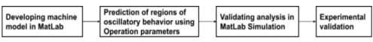

Block Diagram

We aim to identify the parameters responsible for these oscillations and estimate the regions of oscillatory behaviour using analytical methods. This analytical approach enables us to identify these regions efficiently without the need for time-consuming and resource-intensive testing at various flux levels ( V/f ratios ) and fundamental frequencies. We consider the machine parameters, DC-bus voltage, switching frequency, dead-band time, fundamental frequency of operation, and moment of inertia of the machine in our analysis. Furthermore, we compare the obtained analytical results with experimental waveforms of motor currents analyzed using Fast Fourier Transform (FFT). The insights gained from this investigation help to unveil the factors and regions of sub harmonic oscillations while exploring effective mitigation strategies.

### CONTROL OF STATIC POWER CONDITIONERS IN RAILWAY POWER SYSTEM

An increase in the consumption of electricity in the traction sector has also resulted in power quality issues due to the single-phase and non-linear nature of traction loads. 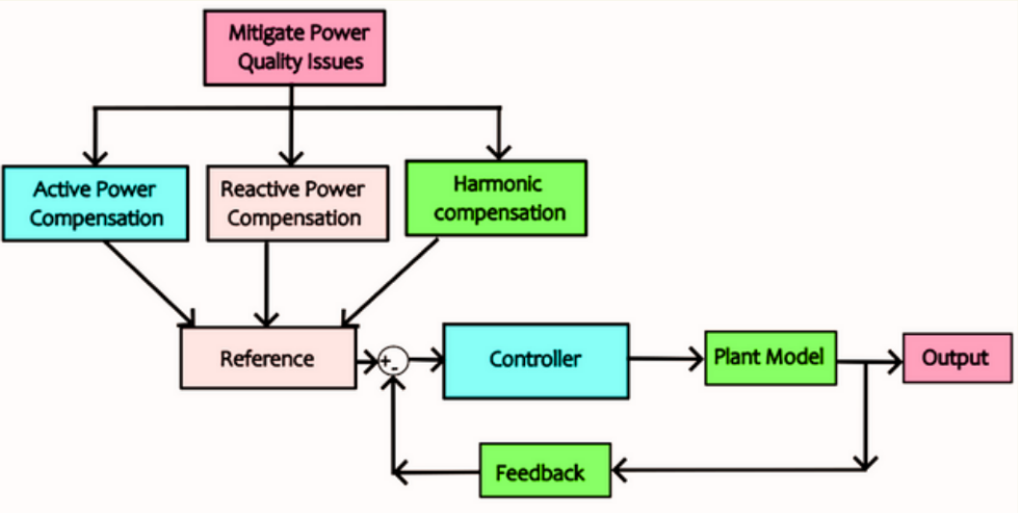

Block diagram explaining the implementation

Due to such loading on the secondary side phases of the traction transformer, negative sequence currents and harmonics are drawn from the primary side. It results in voltage imbalance at the point of common coupling (PCC) located between the grid and traction substation. There are different ways to compensate for power quality issues. They are system configuration-based solutions, power source-based solutions, and equipment-based solutions. The system configuration based focuses on modifying the design of the system like phase shifting, three-phase train implementation, etc. Power source solutions have different special connections of the traction transformer like Delta–wye, Scott, Le Blanc, and Wood Bridge types. The equipment-based classification includes implementing auxiliary devices like static VAR compensator (SVC), railway static power conditioner (RPC), active power quality conditioner (APQC), and hybrid power quality conditioner (HPQC). The study focused on understanding the power quality issues and solutions provided in the literature. Performance of the system has been improved by using RPC along with Scott traction transformer. The same has been validated through simulation.

### IMPACT OF EV AND DG INTEGRATION ON PROTECTION SYSTEM OF DISTRIBUTION NETWORK

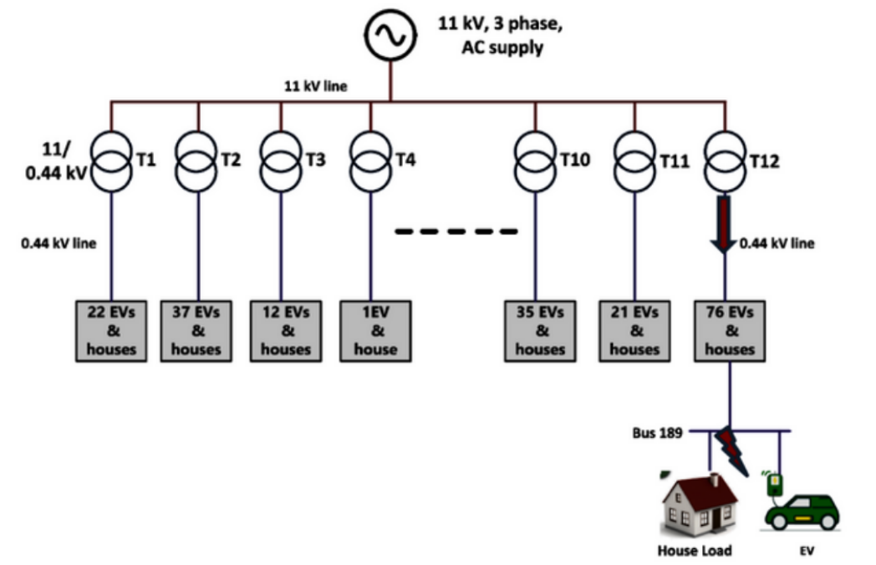

Block Diagram for Simulated Distribution System with EVs and DGs Integration

Protection of traditional distribution systems is relatively easier as they are set up in a radial configuration with the primary source supplying power. The protection system incorporates various components like fuses, auto re-closers, overcurrent relays and circuit breakers. However, the integration of bidirectional power sources such as DGs and EVs can result in various protection challenges, like increasing short-circuit level of the system, change in power flow direction, loss of coordination within relays, protection blinding, sympathetic tripping, unsynchronised reclosing, etc. The study of the impact of EV penetration and DG integration is carried out in four different scenarios, namely Grid to Vehicle (G2V) unidirectional charging mode, G2V charging along with DG integration (G2V+DG), Vehicle to grid (V2G) bidirectional charging, and V2G charging along with DG integration (V2G+DG). The simulation study is carried out on a detailed dynamic model of a real-life distribution system of Delhi developed in DIgSILENT PowerFactory. The analysis of the obtained results facilitates the validation changes required in the existing protection system in response to changing scenarios in real-world distribution networks, such as the integration of DGs and the rise in EV adoption.

### MULTI-FUNCTIONAL GRID FORMING INVERTER BASED DISTRIBUTED GENERATION

The penetration of inverter-based generation has risen exponentially due to environ-mental and economic reasons. Phasing out of synchronous generators can pose a potential threat for the grid, causing problems due to the low overload capacity, lack of inertia, etc., in inverters. Grid forming inverters have proved promising in filling these gaps, and hence, their deployment is slowly increasing across vast geographical boundaries. 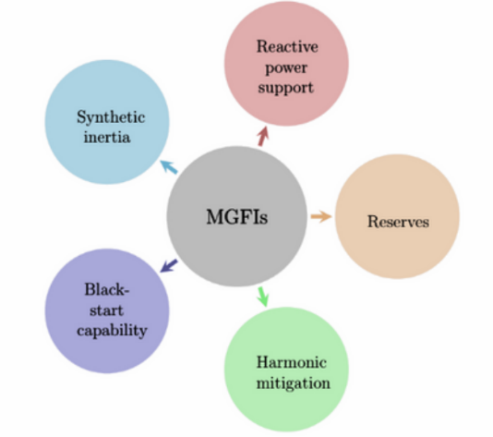

**Capabilities of Multi-functional**

**Grid Forming Inverters (MGFIs)**

However, a number of such inverters spread out over large geographical regions give rise to complex control problems. Therefore, the challenge lies in the development of communication-less strategies to solve these issues. The work involves the development of advanced decentralized control strategies for grid forming inverters that improve steady state and transient responses in addition to power quality. Extensive simulations and experimental validations prove the efficacy of the proposed control strategies.

### PROTECTION OF INVERTER DOMINATED MICROGRIDS

High penetration of inverter interfaced distributed generators (IIDGs) in the distribution network has evolved the concept of power islands, which can operate independently to feed the local network when grid is unavailable. 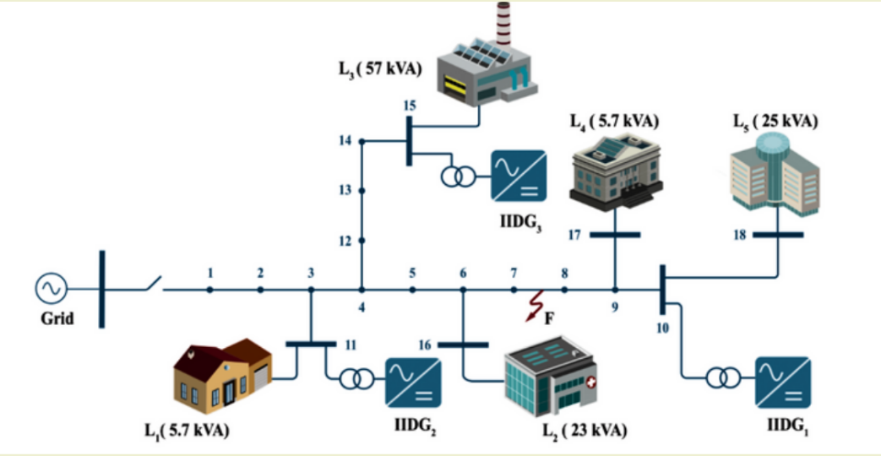

**Modified CIGRE LV benchmark microgrid**

The unconventional fault signatures of IIDGs adversely affects the conventional protective relaying. Also, low short circuit current contribution and control dependent fault behavior of IIDGs creates protection challenges mainly for these power islands. First, the failure of phase and sequence components based conventional fault detection schemes in presence of IIDGs is presented. Then, to address this issue, a negative sequence power-based fault detection method is proposed, which only requires local voltage and current at the relaying point, hence does not depend upon any type of communication. The scheme is validated on an islanded 18-bus CIGRE benchmark network for various fault cases at different inception angles, for various fault resistances and load variations.

### EFFICIENT POWER ELECTRONIC CONVERTER FOR PIEZOELECTRIC ENERGY HARVESTING

Energy harvesting has emerged as a potential method for powering low-power devices like sensor nodes in wireless sensor networks and biomedical electronic implants. Currently, batteries are the main power source for such devices. Replacing or recharging these batteries located in difficult-to-access locations is time and cost intensive. Thus, using ambient energy or waste energy to recharge these batteries is seen as a reliable solution. The underlying principle is to capture and convert ambient energy to a useful form. 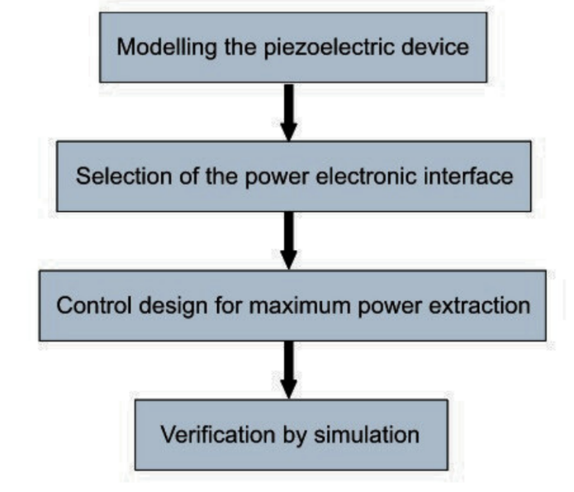

**Flowchart of the process**

Along with this, proper power conditioning is required to suit the load specifications. This study is based on the utilization of the piezoelectric effect for converting vibrational kinetic energy to electrical energy. A model of the piezoelectric device is developed. It is interfaced with a resonant inverter for maximum power extraction from the ambient source. Zero voltage switching is employed to reduce switching losses during inverter operation. Another DC-DC buck converter is used to supply power to the load as per its requirements.

15

### LONG-TERM CARBON CONSTRAINT POWER SYSTEM PLANNING

Carbon emission and climate change was not always the matter of concern for human kinds. But in recent years or decades, ppm of carbon in the atmosphere has reached an absolute peak, which leads to global warming, climate change, extinction of creatures etc. Thus it becomes essential not to add more carbon to the atmosphere. The power sector played the most important role in emitting carbon on generating energy from fossil fuels. In the past, energy generation was planned by considering the cheapest cost and availability of sources which resulted in the overuse of available fossil resources and hence high carbon concentration. It is essential to plan the power sector so that generation should meet the energy demand and emission target. Since demand for electrical energy is growing in every region of the world, renewable energy is an alternate option that can be used to generate electricity at a very low emission factor, but at the same time, cost associated with the installation of renewable is not always economical. This paper aims to develop a model that gives the optimum energy mix for long-term future energy demand. Since planning for the long term from the base year will not give a feasible solution because of the long-year gap and variations in several parameters. Therefore, short-term planning is used to satisfy the energy demand of the next period. Hence a multi-period approach is considered to determine the optimum energy mix for every period. In this work, we have taken different scenarios of future energy demand between 2021 to 2050, different scenarios for reducing demand side emission factor, and determined the optimum path to reach our target demand. The carbon emission pinch analysis technique determines the minimum requirement of low-carbon resources. All the results obtained are verified by other linear programming techniques like the simplex method. When the emission factor is more stringent, the share of renewable becomes more critical in generating sources.

## C. Advanced Combustion and Energy Conversion Technologies

1. ANALYSIS OF FLUID FLOW IN THE INTERSTITIAL SPACE OF A POROUS MEDIA

The existing scenario of conventional sources of energy getting extinct prioritizes the need to use energy from renewable resources. Due to the renewable energy is intermittent Thermal energy storage technologies have earned their importance as promising storage systems in the present and future eras. Single medium thermocline tanks have the popularity to achieve thermal stratification. The result shows that the single medium thermocline tank with a distributor reduces the thermocline thickness and increases the efficiency of the system, visualizing the fluid motion into the porous media Particle image velocimetry measurement is the best method. Investigating the turbulence of the fluid by taking free flow and pore medium with a 5 mm cubic structure glass ball can be analyzed experimentally.

PIV is used to measure the fluid velocity when turbulence interacts with the wall model (surface and subsurface) thus, investigation of the turbulence experimental will give porosity and permeability of media. When the laser passes two pulses at 250 Hz after a precise time difference at the same moment, the camera will able able to capture the two images/frame (1280 X 800 pixels) of the scattered particles. Cross correlation of the two frames when they correlated at peak then it will give the velocity of particles one is

(U =∆X/∆T) AND (V =∆Y/∆T).

1. ALTERNATE FUELS FOR MARINE DIESEL ENGINES - INDIAN NAVY

The Indian Navy is working towards having a Green Strike Group by the end of this decade in accordance with the National Bio-Fuel Policy and the Indian Navy Environment Conservation Roadmap (INECR). Therefore it has become imperative to identify and implement clean burning fuels without compromising on India’s maritime dominance in the blue waters. 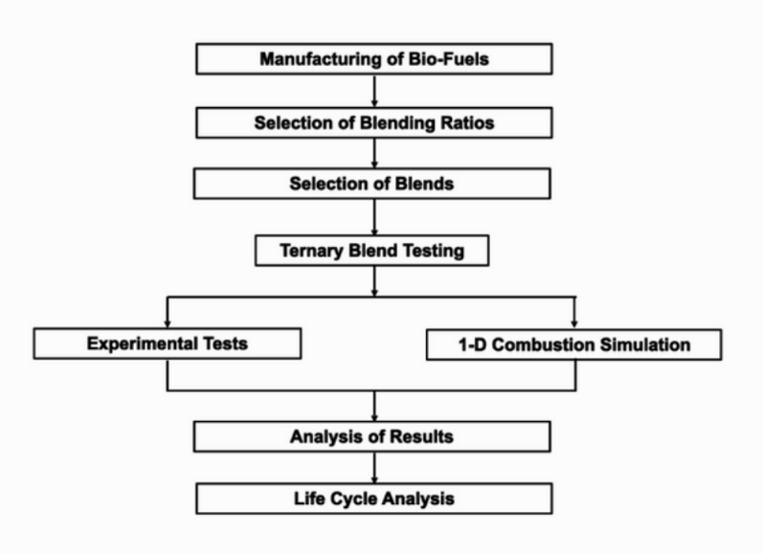

The Indian Navy is presently using High Flash High Speed Diesel (HFHSD) for propulsion and power generation. Target of this project is to identify fuel blends (with bio-fuels) which may provide performance comparable to FSHSD **Process Flow for Selection** whilst reducing emissions **of Alternate Fuel Blends**

without undertaking any major modifications to the marine engines and associated shipboard systems. Ternary blends (FSHSD + Bio-Diesel + Bio-Ethanol) were arrived upon as the tentative solution towards countering the limitations of using standalone Bio-Diesel blends. Further, considering sustainability as one of the cornerstones for evaluation as per INECR, Used Cooking Oil (UCO) based Bio-Diesel and Bio-Ethanol (from waste food crops) are being used as the components of the targeted Ternary blend. The most suited blend will be selected based on experimental results of trials on test engines and 1-D combustion simulation. This blend will then be further assessed from the standpoint of shelf life and long term utility.

1. COLOR RATIO PYROMETRY FOR FLAME TEMPERATURE MEASUREMENT

Pyrometry is a crucial technique for measuring flame temperature in various applications such as furnaces, laboratories, and reaction energetics. Two-color pyrometry is a non-contact method that uses two different wavelengths of light to determine an object's temperature. Color ratio pyrometry, a subset of two-color pyrometry, uses the intensity ratio of two colors to calculate an object's temperature. 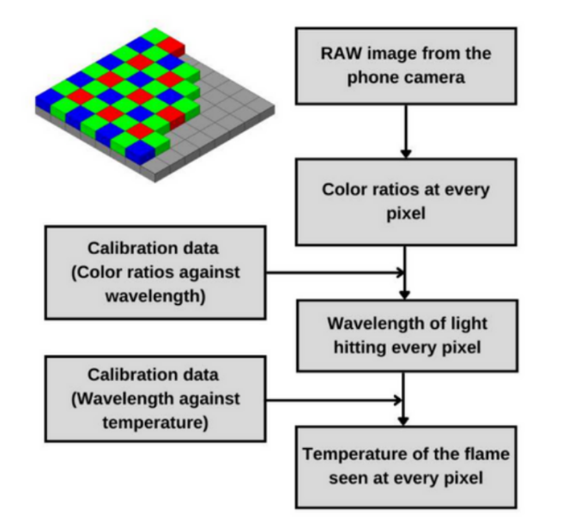

**Block Diagram of the Implmentation** The study explores the possibility of using a smartphone camera as a pyrometer, as it measures three wavelengths (Red, Green, and Blue).

Three smartphones are used and calibrated with a monochromator to obtain the camera sensor's spectral response curves. These curves are used with power measurements to plot color ratio curves like R/G against the wavelength. Wavelength vs temperature curves are later obtained for each phone using a blackbody calibration furnace.

The final product is a mobile application that inputs a raw image and outputs a detailed temperature analysis of the flame. The study also explores the possibility of creating common calibration data for all smartphones and using the Raspberry Pi (RPi) and its camera module as a pyrometer instead of a smartphone.

1. MACHINE LEARNING APPLICATION FOR GAS TURBINES IN INDIAN NAVY

Marine Gas Turbine (GT) has been the workhorse of propulsion and power generation onboard Indian Navy warships over the past six decades. DT59 (engine index number) GTs are being presently utilized for propulsion of P15, P15A and P15B class of ships of the Indian Navy. GTs have an intricate design which entails operators and maintainers to possess the highest level of professional competence for seamless operation. 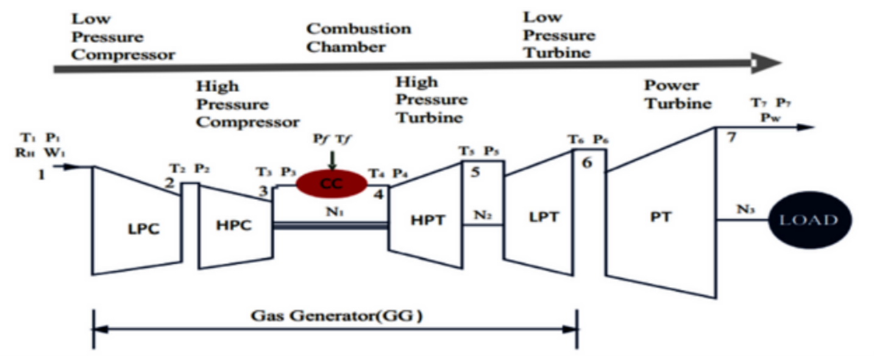

**General Layout of Triple Shaft Marine Gas Turbine**

Analysis and prediction of key operational parameters and maintenance routines of these GTs is vital towards improving their utilization and reducing down time. Therefore, the target of this project is to predict the performance parameters of a DT59 gas turbine using a machine learning model. This project is the first of its kind utilizing Machine learning to optimize the output parameters and operational availability DT59 Gas Turbine engines. Archived and present-day data from engine log books is being compiled from the ships for training the model. This template can also be utilized for predicting the performance of other machinery fitted onboard Indian Navy warships by applying the concepts of machine learning. This project will also provide one of the early templates of python libraries to be imported and required codes in which only the input data in required format will have to be substituted to get the desired output. This may be considered as a major step in using machine learning to optimize the performance and maintenance routines of machinery for maximum operational availability

1. MACHINE LEARNING BASED MODELLING AND PREDICTIVE CONTROL OF MAXIMUM PRESSURE RISE RATE IN RCCI ENGINE

Reactivity Controlled Compression Ignition (RCCI) is an attractive low temperature combustion (LTC) technology that exhibits potential for reducing nitrogen oxides (NOx), and soot emissions while simultaneously enhancing fuel conversion efficiency at certain engine operating conditions, compared to conventional diesel engines. Effective control of the maximum pressure rise rate (MPRR) is critical for the safe and efficient operation of RCCI engines at varying engine loads. This study employs a data-driven modeling (DDM) approach that utilizes a least square-support vector machines (SVM) algorithm to develop a linear parameter-varying (LPV) representation of MPRR, mid-point of combustion (CA50), and indicated mean effective pressure (IMEP) for RCCI combustion. The LPV model is integrated into a model predictive controller (MPC) to regulate CA50 and IMEP while constraining MPRR. The performance of the proposed controller is evaluated using closed-loop simulations, where a neural network model is trained, with data available in literature, to accurately predict CA50, IMEP, MPRR and cylinder pressure and temperature at the start of combustion (SOC). The trained neural network model achieved high prediction accuracy with R2 values greater than 0.9 for all features. The proposed DDM approach has the potential to enhance the control of RCCI combustion, leading to improved engine performance and reduced emissions.

1. UTILIZING MACHINE LEARNING FOR FINDING APPROPRIATE ADDITIVES TO PREVENT WAX CRYSTALLIZATION

Due to low temperature in the surrounding of crude oil transportation pipelines, wax starts to aggregate at the inner surface of the pipelines and forms a thick layer which restricts the flow of oil and at times even clogs the pipeline. The conventional processes to restart the clogged pipeline are costly and difficult to perform. PPDs (Pour point depressants) are a cheaper and better alternative for preventing this wax precipitation. To study the effect of PPDs on each crude oil and to test or experiment all the PPDs on a crude oil is difficult and time consuming. 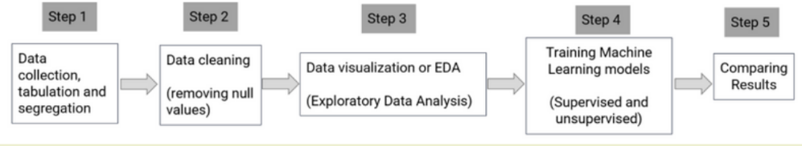

**Block Diagram for Machine Learning Implementation**

Hence to overcome this problem, a machine learning approach is implemented. This will find the general trends of PPDs and crude oils and will predict the suitable PPDs for corresponding crude oils, based on the training data. This data is collected from various research articles and used for training different supervised and unsupervised machine learning models. Hence given the composition and other data of crude oils such as the API gravity, pour point and weight percentages of asphaltene and wax present, etc, the corresponding suitable PPDs are predicted. And for testing the accuracy, the results from all the models are crosschecked.

1. FEASIBILITY STUDY OF DOC FOR RCCI ENGINE

This work presents a simulation-based study of a light duty mini truck operating on diesel fuel in the Indian context, as part of a life cycle greenhouse gas emission analysis. The study involved the design of a Mahindra Maxximo vehicle in AVL Cruise software, which was used to produce emissions characteristics over a legislated driving cycle.

Initially, a conventional diesel engine vehicle was built in AVL Cruise and emission maps were generated under steady-state operating conditions. This was followed by the inclusion of maps generated on low-temperature combustion (LTC) regime data gathered from a dual-fuel reactivity-controlled compression ignition (RCCI) engine. For emission analysis, an after-treatment system was built in AVL Boost and integrated with the existing AVL Cruise model. The results of the study revealed that the LTC operation maps produced lower NOx and soot emissions and higher CO and hydrocarbon emissions compared to the conventional diesel engine maps. Additionally, the effect of after treatment system in AVL Boost was investigated.

The study provides valuable insights into the potential of LTC and after-treatment systems in reducing greenhouse gas emissions from mini trucks in the Indian context. The methodology presented in this work could be extended to other vehicle types and driving cycles, contributing to the development of cleaner transportation systems.

## 

## 

## D. Energy Storage and Conversion

## Technologies

### NOVEL MXENE BASED CATALYSTS FOR HYDROGEN STORAGE APPLICATIONS IN AUTOMOBILES

In light of increasing environmental degradation and decline of nonrenewable energy sources over the last few decades, hydrogen fuel has been seen as a key alternative source of renewable energy. To attain the desired hydrogen economy, several materials for hydrogen storage have been developed. Magnesium hydride has become a hot spot in the research of hydrogen storage materials, due to its high theoretical hydrogen storage capacity and also high gravimetric and volumetric hydrogen capacities of ca. 7.6 wt.% and 111 g/L, respectively. However, the bottleneck to the wide applications of Magnesium hydride as a commercial source of hydrogen fuel is the 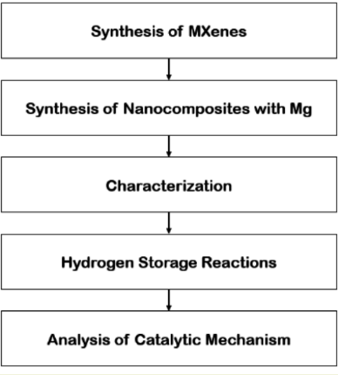

slow kinetics of hydrogen **Block Diagram for Hydrogen**

de/absorption **Storage in Mxene Based Catalysts**

MXene, a novel 2D transition metal carbide has demonstrated the dual roles of storing hydrogen and enhancing the hydrogen evolution reactions of lightweight metal hydrides especially Magnesium Hydride. Therefore, two batches of TiC2Tx MXenes were prepared by adding 1 g of Titanium Aluminium Carbide powder to 10 mL of 40% HF-etchant and kept for stirring at room temperature for 36h and 24h. MXene and Mg nanocomposites were prepared by ball milling for 60h. This project, provides insights into MXenes, their recent applications as potential materials for storing hydrogen, and as functional additives for enhancing the hydrogen reaction of Magnesium Hydride.

### 

### CONSTRAINED OPTIMIZATION OF CATHODE PRESSURE AND MEMBRANE THICKNESS FORA PEM ELECTROLYZER

PEM Electrolyzers play a cardinal role in the hydrogen economy due to their high operating current densities, fast dynamic response, and the possibility of operating at high differential pressures (cathode pressure higher than anode) to reduce the energy needed for compression of hydrogen. 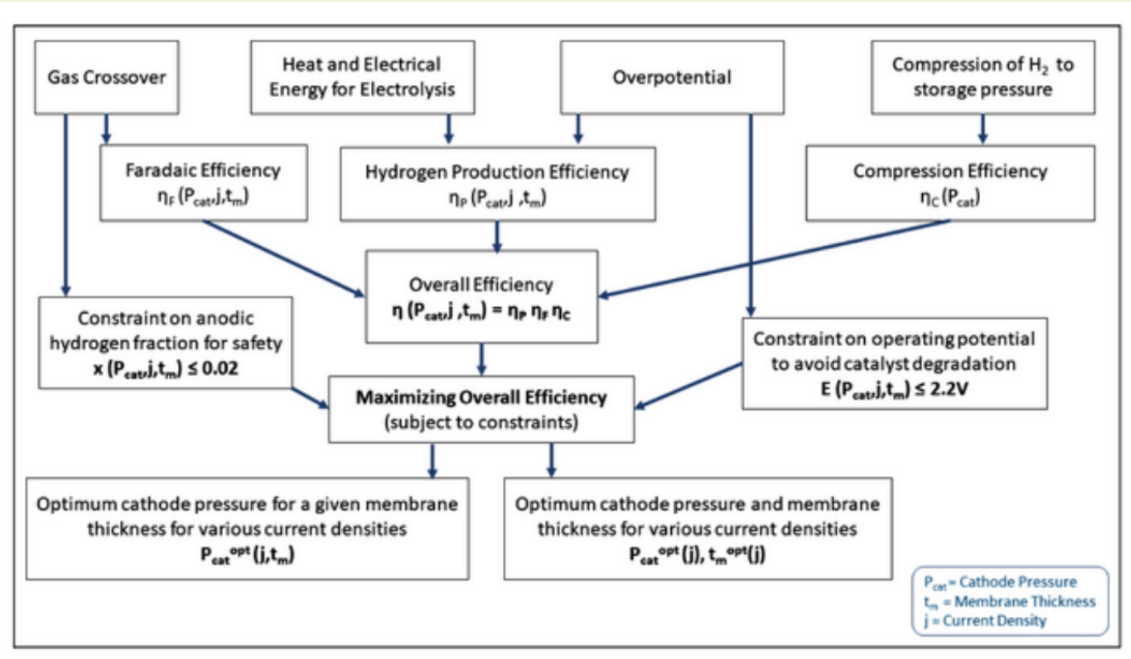

**Block diagram for finding optimum cathode pressure- given membrane thickness and varying densities**

However, operating at high cathode pressure necessitates using a thicker electrolyte membrane to mitigate gas crossover and withstand differential pressures, which decreases the voltage efficiency of the electrolyzer cell. In this study, a PEM electrolyzer system is modeled to evaluate the overall system efficiency, which is maximized to find optimum cathode pressure and membrane thickness across a range of current densities, subject to constraints on the anodic hydrogen volume fraction (maximum 2%) to ensure safe operating condition, and on the operating potential (maximum 2.2V) to avoid catalyst degradation. From optimum cathode pressure obtained for various membrane thicknesses across a range of current densities, indicated that the Nafion 115 membrane with a thickness of 127 μm proved to be an ideal balance between ensuring safe and efficient operation across the current density range of 0.001-3 A/cm2. Through the proposed methodology, we can choose the right membrane thickness and operating pressure for a PEM electrolyzer.

### THERMAL MANAGEMENT OF FUEL CELLS FOR APPLICATION IN ELECTRIC VEHICLES

The escalating transport demand over the past decade has intensified the need to replace internal combustion (IC) engines with better alternatives like fuel cells that can simultaneously provide superior performance and diminished emissions. 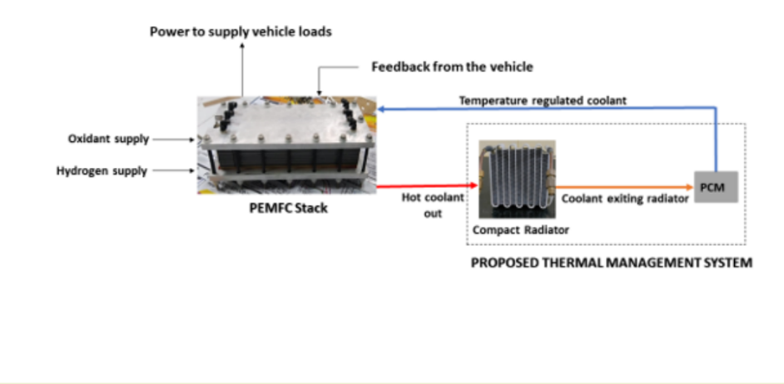

The radiators that are used in fuel cell-based electric vehicles are at least twice the size of IC engine radiators. This leads to an increase in mass, volume, and fuel consumption. The undertaken study proposes a reduction in radiator size by storing thermal energy in phase change materials. This work presents a generalized sizing method for the recommended thermal management system, using a simple mathematical approach based on Pinch Analysis. The optimization studies show the possibility to bring down the minimum radiator area requirement in a fuel cell vehicle like the 2022 Toyota Mirai by 5.5 times by using around 13 kg of Paraffin Wax along with it. The proposed methodology is realized by analysing a few representative parameters like ambient temperature, drag area and curb mass of the vehicle, maximum allowable temperature rise in fuel cells, etc. In addition, the study also estimates the minimum required radiator areas for a few commercial fuel cell vehicles in the Indian environment.

### DEVELOPMENT OF HIGH-VOLTAGE CATHODE AND SOLID-ELECTROLYTE FOR NEXT GENERATION LI-ION/LI-METAL BATTERIES

Lithium cobalt oxide (LCO) is a well-known cathode due to its distinctive structure and superior electrochemical relationship. However, electrochemical operation at a voltage of more than 4.5 V and at a high rate, a requirement of today's battery technology, LCO losses its structural stability and related battery safety. The LCO cathode has been coated with a thin layer of lithium cobalt manganese oxide (LiCo0.5Mn1.5O4, or LCMO), and synthesized using microwave-assisted heating. The as-prepared cathode structure revealed very less manganese (III) ion (Mn3+) diffusion into the LCO, which increased its lattice parameter and favored the Li-ion diffusion in the LCO cathode, enabling a faster cycling rate for longer periods. The full cell is fabricated using LCMO-coated LCO as a cathode and graphite as an anode. The n/p ratio was optimized to achieve superior full-cell performance. To demonstrate the practical relevance of the research, we developed a 2 Ah pouch cell. The as developed cathode material was used to fabricate all solid-state cell and its electrochemical characterization was carried out. The interface between Li metal and solid-state electrolyte was stabilized through lithiophilic and lithiophobic kind of gradient morphology.

### AN ATTRACTIVE PARADIGM ON INTERFACIAL STRUCTURAL MODE OXYGEN ELECTROCATALYST: ZINC AIR BATTERY

Metal-air batteries propose an option for high energy density and low-cost storage. Developing a high-efficiency and durable bifunctional electrocatalyst for both the oxygen reduction reaction (ORR) and oxygen evolution reaction (OER) is critical for the widespread application of rechargeable zinc−air (Zn−air) batteries. 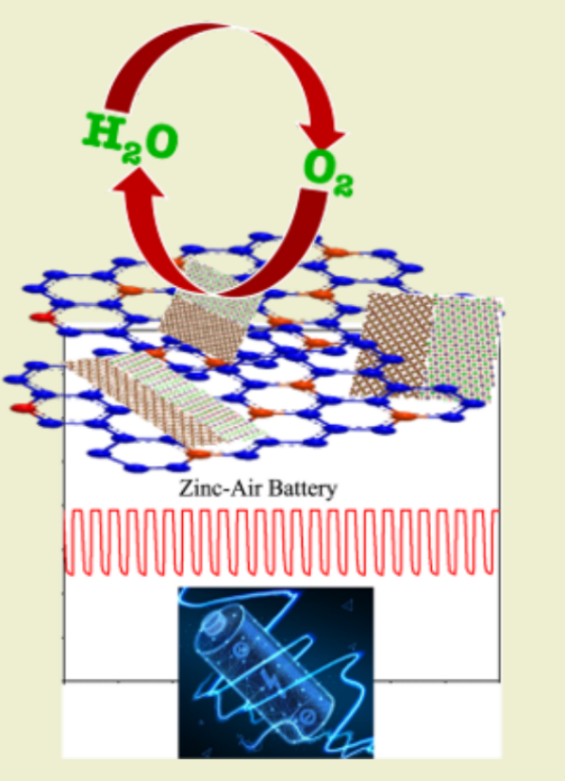

Herein, we propose a controllable interface (nickel cobalt layered double hydroxide with cerium oxide) engineering concept applied on nitrogen-doped Vulcan carbon (N@C) to design a noble-metal-free bidirectional catalyst (N@C_LDH-CeO2) via two steps reproducible wet chemical route. The multifunctional hybrids interface may serve as a hydrogen acceptor and thus optimize the adsorption behaviors to break the OH*— OOH*, which can scaling-up the relationship in OER. Whereas dopant pyridinic N in N@C, creates the active sites for oxygen reduction reaction, carbon atoms next to pyridinic N are recommended to be the active sites with Lewis’s basicity at which O2 molecules are adsorbed as the initial step of the ORR. Benefiting from the advantages mentioned above of interfaces, N@C_LDH-CeO2 offers superior oxygen reduction reaction and oxygen evolution reaction catalytic activity with an ultralow polarization gap (∆E) of 0.76 V, as well as preferable durability and rapid reaction kinetics.

### BIFURCATION ANALYSIS OF TWO-PHASE NATURAL CIRCULATION LOOP

Natural circulation loop are gravity-based heat exchangers, driven on buoyancy, and utilized in a variety of commercial settings. The idea of passive heat exchange in NCL systems is appealing since the fluid circulation can be maintained without the assistance of an externally driven device (like a pump). The generation of time-varying non-linearities in the two-phase dynamical system, causing the flow to change from a steady-state regime to either a flow-reversal or oscillatory regime, both being not acceptable, is one potential issue with relying solely on buoyancy. 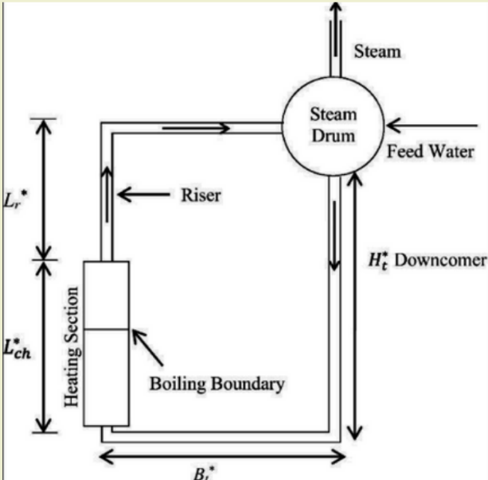

This study aims to perform bifurcation analysis of a two-phase flow system using the MATCONT software. The two-phase flow system under consideration is modelled by a set of ordinary differential equations, which describe the dynamics of the system. A one-dimensional homogeneous equilibrium model is used to describe the density wave oscillation in the heated channel. In this analysis, the different types of bifurcations that can occur in the system, such as saddle-node, Hopf, and pitchfork bifurcations will be explored. We will also investigate the effect of varying system parameters on the stability of the system. The results of this analysis will provide insight into the behaviour of the two-phase flow system and help to identify regions of parameter space where the system is stable or unstable.

**2024 Abstracts and Presentations**

8

## Renewable Energy and Sustainability

* + 1. Assessment of trustworthiness of human-automation interaction in nuclear power plants.

|  |  |  |  |  |  |  |  |  |  |  |  |  |  |  |  |
| --- | --- | --- | --- | --- | --- | --- | --- | --- | --- | --- | --- | --- | --- | --- | --- |
| 31/03/2024 20:29:57 | samrendraroy55@gmail.com | Samrendra Roy | 19d170026 | B.Tech. + M.Tech. | 5 |  | Assessment of trustworthiness of human-automation interaction in nuclear power plants. | Prof. Suneet Singh | https://drive.google.com/open?id=1v6zt91IUZKbB6OMvmhHHfVjw-R_kpsu3, https://drive.google.com/open?id=1sz-_LpC1Gxc2IVHr6O4hV2fCXDcn1Nog | [Abstract - Samrendra Roy.docx](https://drive.google.com/open?id=1sz-_LpC1Gxc2IVHr6O4hV2fCXDcn1Nog) | [Graph - Samrendra Roy.png](https://drive.google.com/open?id=1v6zt91IUZKbB6OMvmhHHfVjw-R_kpsu3) |  |  | [Abstract - Samrendra Roy.docx](https://drive.google.com/open?id=1sz-_LpC1Gxc2IVHr6O4hV2fCXDcn1Nog) | [Graph - Samrendra Roy.png](https://drive.google.com/open?id=1v6zt91IUZKbB6OMvmhHHfVjw-R_kpsu3) |

**Keywords:**

Integrated Probabilistic Risk Assessment (I-PRA), Automation Trustworthiness, Probabilistic Validation (PV), AI-Based Automated Firewatch, Nuclear Power Plants.

The nuclear industry is progressively integrating automation technologies into Nuclear Power Plants(NPPs). To make informed decisions about large-scale investments in automation technologies specifically used for safety critical applications, stakeholders require robust evidence of their transparency, trustworthiness, and operational acceptability. This study introduces a risk-informed approach to evaluate automation trustworthiness by leveraging and making advancements to the Integrated  Probabilistic Risk Assessment (I-PRA) methodological framework and the Probabilistic Validation (PV) methodology that were previously developed by some of the authors. I-PRA connects simulation models of underlying physical and social phenomena with the existing plant PRA model through a probabilistic interface. This study advances the I-PRA framework to explicitly capture relationships between the plant risk metrics and input parameters associated with the underlying human-automation-physics interactions. This paper currently includes initial results of an ongoing case study evaluating the trustworthiness of an Artificial Intelligence (AI)-based automated firewatch system suggested for use in NPPs.

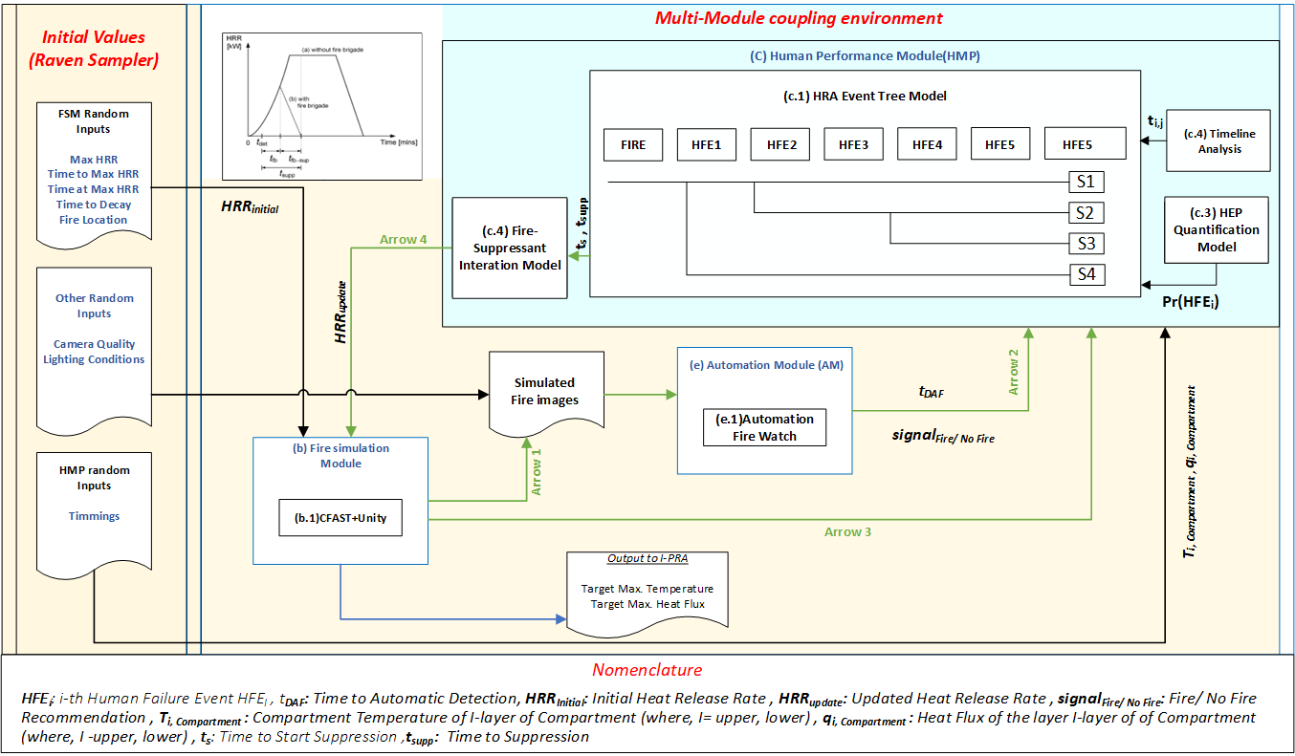

* + 1. Modelling Net Zero Scenarios for the Indian Industrial Sector by 2070

|  |  |  |  |  |  |  |  |  |  |  |  |  |  |  |  |
| --- | --- | --- | --- | --- | --- | --- | --- | --- | --- | --- | --- | --- | --- | --- | --- |
| 30/03/2024 21:51:44 | jaydeep222000@gmail.com | Jaydeep Sharma | 19D170011 | B.Tech. + M.Tech. | 5 | Renewable Energy and Sustainability | Modelling Net Zero Scenarios for the Indian Industrial Sector by 2070 | Professor Venkatasailanathan Ramadesigan | https://drive.google.com/open?id=1FAkeF6HIiu5Ku7SvUxr4l1Dd5OSXW-SR, https://drive.google.com/open?id=1QKLUmq-U-q6aXml54dhhxtyeUo-SNDBa | [Abstract_DDP_19D170011 - Jaydeep Sharma.pdf](https://drive.google.com/open?id=1FAkeF6HIiu5Ku7SvUxr4l1Dd5OSXW-SR) | [Abstract_Energy_Day - Jaydeep Sharma.png](https://drive.google.com/open?id=1QKLUmq-U-q6aXml54dhhxtyeUo-SNDBa) |  |  | [Abstract_DDP_19D170011 - Jaydeep Sharma.pdf](https://drive.google.com/open?id=1FAkeF6HIiu5Ku7SvUxr4l1Dd5OSXW-SR) | [Abstract_Energy_Day - Jaydeep Sharma.png](https://drive.google.com/open?id=1QKLUmq-U-q6aXml54dhhxtyeUo-SNDBa) |

Key Words: Net-zero emissions, Indian industrial sector, Decarbonization goals, Sustainable industrial landscape

The transition towards a net-zero emissions future demands comprehensive planning and analysis, particularly in high-emitting sectors such as industry. Our work focuses on modelling net-zero scenarios for the Indian industrial sector, with a primary emphasis on key industries such as Iron & Steel and Cement. By projecting future demand based on current per capita consumption trends and potential trajectories, we aim to provide insights into the scale of transformation required to align with the decarbonisation goals set by the government, targeting 2070. The supply side of the equation will be modelled using the TIMES (The Integrated MARKAL-EFOM System) framework developed by the Energy Technology Systems Analysis Programme (ETSAP) under the International Energy Agency (IEA). This modelling approach enables us to understand the economic implications associated with decarbonising industrial processes and infrastructure. By integrating demand projections with supply-side modelling, our study offers a holistic perspective on the challenges and opportunities inherent in achieving net-zero emissions in the Indian industrial sector. The findings of this research are expected to inform policymakers, industry stakeholders, and researchers, facilitating the design of effective strategies and policies to accelerate the transition towards a sustainable and low-carbon industrial landscape in India.

* + 1. Biomass-derived activated carbon for supercapacitor application

|  |  |  |  |  |  |  |  |  |  |  |  |  |  |  |
| --- | --- | --- | --- | --- | --- | --- | --- | --- | --- | --- | --- | --- | --- | --- |
| 30/03/2024 12:11:14 | shubhamkr@iitb.ac.in | Shubham Kumar | 18I170005 | M.Sc + Ph.D | 4 | Renewable Energy and Sustainability | Biomass-derived activated carbon for supercapacitor application | Prof. Sandeep Kumar | https://drive.google.com/open?id=1Ttsk5ryWGv4aXw664kZ5g_mwRfxFsL06 | [Abstract_Shubham Kumar - Shubham Kumar.docx](https://drive.google.com/open?id=1Ttsk5ryWGv4aXw664kZ5g_mwRfxFsL06) |  |  |  | [Abstract_Shubham Kumar - Shubham Kumar.docx](https://drive.google.com/open?id=1Ttsk5ryWGv4aXw664kZ5g_mwRfxFsL06) |

**Keywords:**

Biomass, Chemical activation, Activated carbon, Supercapacitor

Biomass represents an eco-friendly, and cost-effective source for sustainable energy generation, as well as a clean feedstock for green chemistry and bioproducts development. Waste biomass is a reliable and cheap precursor for the production of activated carbon. The carbonizing temperature and chemical treatment method determine the attributed properties of activated carbons in terms of specific surface area, pore size distribution and tuning nature of surface functionality required for the fabrication of electrode material of supercapacitor. Generally, the two primary routes used in the synthesis of activated carbon are physical and chemical activation process. Despite of the application of subabul sawdust derived activated carbon (SAC) in CO2 adsorption, water and gas purification, it also exhibits the flexibility of fabricating electrode materials for supercapacitor with well-defined geometries. In the present study, subabul sawdust derived activated carbon was prepared by the chemical activation process. Precursor mixed with optimized ratio of activating agent synthesized at 800°C temperature for 3 hours generated efficient activated carbon in terms of specific surface area and pore size distribution. Characterization techniques such as X-ray diffraction, Raman spectroscopy, fourier-transfer infrared spectroscopy, N2 physisorption, and field emission scanning and transmission electron microscopy were performed to assess the physicochemical properties of the carbon material. These characterization studies reported the amorphous nature, surface functional group and porous structure of activated carbon material which qualifies its application as electrode for supercapacitor.  The process of synthesizing activated carbon substantially increased the surface area with interconnected porous morphology that enhance charge transport and accumulation. The electrochemical characterization of activated carbon was conducted in aqueous electrolyte with different mass loading using technique such as cyclic voltammetry, galvanostatic charge-discharge test and electrochemical impedance spectroscopy. Distortion in cyclic voltammetry and charge-discharge curve from its symmetrical behavior reported pseudocapacitance effect. Electrochemical performance of SAC is yet to be optimized in three electrode system and as well as two electrode system. This study has shown that SAC has a significant potential to be utilized as an electrode material for electrochemical energy storage system.

v. Feasible Operating Region of Unbalanced Distribution Networks with Distributed Photovoltaics

|  |  |  |  |  |  |  |  |  |  |  |  |  |  |  |  |
| --- | --- | --- | --- | --- | --- | --- | --- | --- | --- | --- | --- | --- | --- | --- | --- |
| 025/03/2024 23:26:50 | manorathp1@gmail.com | Manorath Prasad | 194174001 | Ph.D | 4 | Renewable Energy and Sustainability | Feasible Operating Region of Unbalanced Distribution Networks with Distributed Photovoltaics | Prof. Zakir Hussain Rather | <https://drive.google.com/open?id=1tLMzzCh7fPtiFBU0LfAG9YSpUNGJuy2p> | [energy day - Manorath Prasad.docx](https://drive.google.com/open?id=1tLMzzCh7fPtiFBU0LfAG9YSpUNGJuy2p) |  |  |  | [energy day - Manorath Prasad.docx](https://drive.google.com/open?id=1tLMzzCh7fPtiFBU0LfAG9YSpUNGJuy2p) |  |

Keywords: Active distribution network (ADN), bulk power system (BPS), feasible operating region (FOR), distribution systems, grid support, TSO-DSO coordination, operating envelopes

Abstract: Amidst rising distributed generation and its potential to play an active role in grid management, this study presents a new realistic approach to determine the operational space and flexibility potential of an unbalanced active distribution network (ADN). The feasible operating region (FOR) of an ADN is constituted by its range of active-reactive power exchange with the bulk power system (BPS) without breaching network constraints. This study explores the potential of highly penetrated single- and three-phase distributed photovoltaics (DPVs) and voltage-sensitive loads to obtain FOR at different ADN operating points. The cumulative response of Volt-Var controlled DPVs and voltage-sensitive loads determines the BPS-ADN

interconnection power flow, whose feasibility is ensured with respect to voltage magnitude and voltage unbalance constraints. Further, the correspondence of FOR with the tap-settings of BPS-ADN substation transformer enables a novel feature to traverse throughout the available operating region and facilitate BPS-ADN power coordination. Additionally, a nodal sensitivity-based adjustable Volt-Var control scheme is proposed for DPVs considering both voltage magnitude and voltage unbalance constraints, ultimately improving the FOR.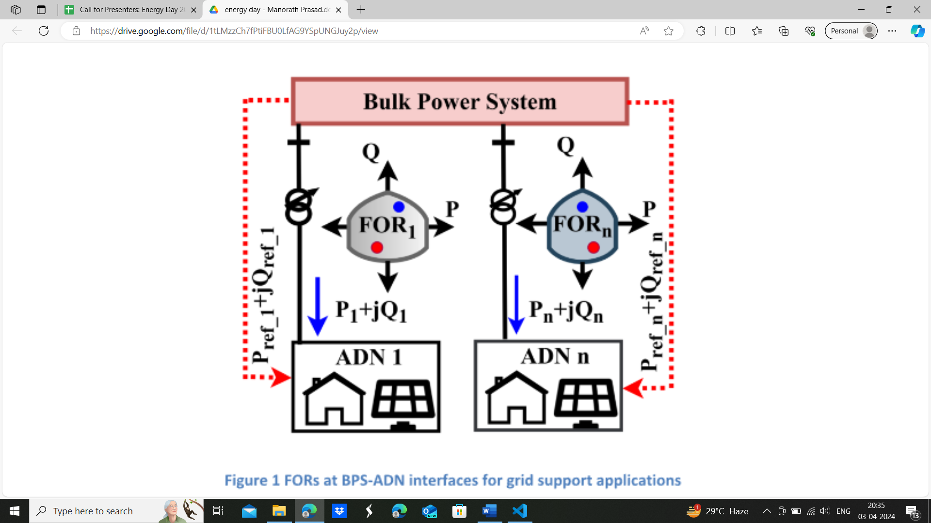

Figure 1 FORs at BPS-ADN interfaces for grid support applications

Vi. Oxy-steam gasification of biomass for hydrogen-rich syngas generation

|  |  |  |  |  |  |  |  |  |  |  |  |  |  |  |  |
| --- | --- | --- | --- | --- | --- | --- | --- | --- | --- | --- | --- | --- | --- | --- | --- |
| 25/03/2024 18:09:14 | gaurav.prajapati@iitb.ac.in | Gauravkumar Prajapati | 17i170014 | M.Sc + Ph.D | 7 | Renewable Energy and Sustainability | Oxy-steam gasification of biomass for hydrogen-rich syngas generation | Prof. Sandeep Kumar | https://drive.google.com/open?id=1lRcYN4vaTxAbt7ZqLUBNuFSSo3Vc49bU, https://drive.google.com/open?id=1JMRF9qlrUFLl-PaCmyIYIM9fSioZ1tF5 | [Abstract_17i170014_EnergyDay - Gaurav Prajapati.docx](https://drive.google.com/open?id=1lRcYN4vaTxAbt7ZqLUBNuFSSo3Vc49bU) | [17i170014 - Gaurav Prajapati.png](https://drive.google.com/open?id=1JMRF9qlrUFLl-PaCmyIYIM9fSioZ1tF5) |  |  | [Abstract_17i170014_EnergyDay - Gaurav Prajapati.docx](https://drive.google.com/open?id=1lRcYN4vaTxAbt7ZqLUBNuFSSo3Vc49bU) | [17i170014 - Gaurav Prajapati.png](https://drive.google.com/open?id=1JMRF9qlrUFLl-PaCmyIYIM9fSioZ1tF5) |

**Keywords:**

Biomass, Hydrogen, Gasification, Syngas, Aspen plus

Green hydrogen is one of the emerging sustainable fuel which can be produced from easily available biomass through gasification. The use of steam in oxy-steam gasification as an oxidizer with oxygen enhances hydrogen content in produced syngas. System-level analysis is performed to check feasibility and energy efficiency. A comprehensive equilibrium model for oxy-steam gasification of biomass for H2-rich syngas production has been developed using Aspen PLUS process simulation software and validated with experimental data available in the literature. Increased gasification temperature from 700 ℃ to 1000 ℃ resulted in a monotonic reduction in H2 and CO2 content in syngas with a subsequent increase in CO content. This increase in gasification temperature also results in an increase in syngas lower heating value (LHV) and cold gas efficiency (CGE) from 7.55 to 8.34 MJ/Nm3 and 63.5 to 64.85 %, respectively.  The increase in equivalence ratio has an opposing trend, both on syngas LHV and CGE.  An increase in steam to biomass ratio increases syngas H2 content by about 8 % at an expense of approximately 21.5 % in CGE.

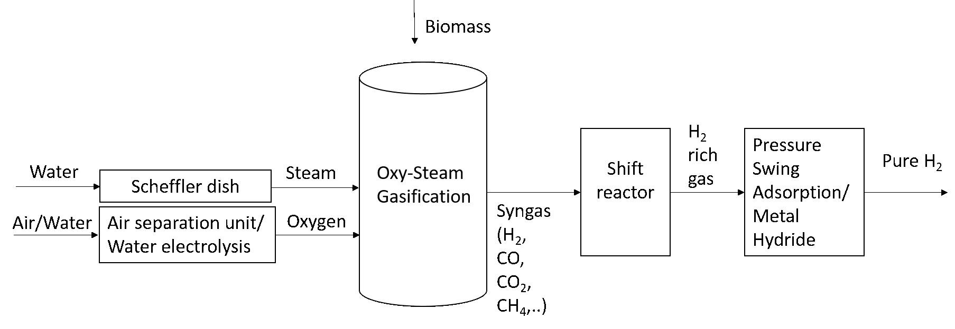

Figure 2 Block diagram for hydrogen generation through oxy-steam gasification

1. Investigation and characterisation of potential induced degradation in crystalline silicon photovoltaic module

|  |  |  |  |  |  |  |  |  |  |
| --- | --- | --- | --- | --- | --- | --- | --- | --- | --- |
| 04/04/2024 20:54:01 | ravikr@iitb.ac.in | Ravi Kumar | 18i170013 | M.Sc + Ph.D | 4 | Investigation and characterisation of potential induced degradation in crystalline silicon photovoltaic module | Prof. Rajesh Gupta | <https://drive.google.com/open?id=1blbMyc_U3BnRQrH9r16iDFDucOzkop6v> | <https://drive.google.com/open?id=1_mqj9zg8viltamzodcXBVRPtAgV_FRxY> |

**Keywords:**

Potential-induced degradation (PID), Infrared imaging, photovoltaic (PV) module, cell power

Potential-induced degradation-shunting (PID-s) is a severe degradation mechanism in photovoltaic (PV) cells that significantly impact module performance. To prevent further degradation, periodic monitoring of PID-s is essential. Current-voltage (*I-V*) characteristics and electroluminescence (EL) imaging are commonly used for quantitative performance evaluation of PID-s affected PV modules. However, conducting *I-V* measurements in the field is time-consuming, while EL imaging has limitations for severely PID-affected cells with no EL emission. To address these challenges, this abstract proposes the use of infrared thermography as an alternative evaluation technique. Infrared imaging offers a faster and more efficient approach, enabling the visualization of temperature distributions even in severely PID-affected PV cells where EL imaging falls short. This paper presents insights exploring the possibility of a correlation between PV cell temperature and power output. Analysis of shunting using simulations confirms the one-to-one relationship between power output and heat dissipation. Experimental measurements of cell power exhibit a strong correlation with the average cell temperature in a PV module.

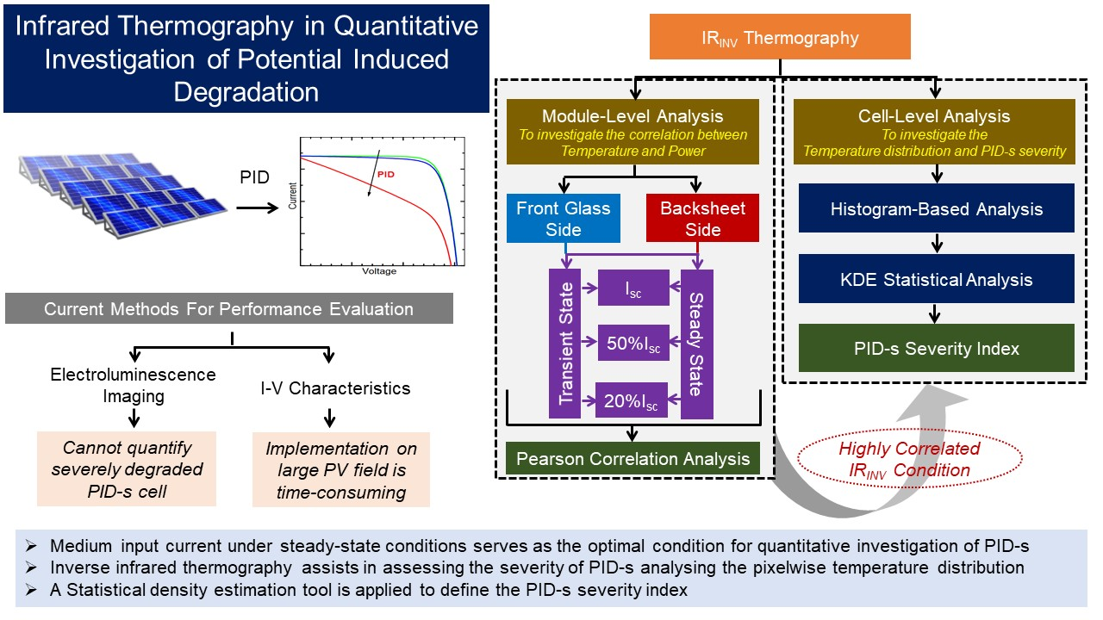

Figure 3 Research gap and methodology

## Power Electronics and Smart Grids

* + 1. Direct Torque Control of Induction Motor Drives

|  |  |  |  |  |  |  |  |  |
| --- | --- | --- | --- | --- | --- | --- | --- | --- |
| 31/03/2024 23:00:36 | 22m1350@iitb.ac.in | Vipul Mishra | 22m1350 | M.Tech. | 2 | Direct Torque Control of Induction Motor Drives | Prof. Siddavatam Ravi Prakash Reddy | <https://drive.google.com/open?id=17fPQ1gUpZprGlyMmP70Qx5NNPezWB-Ii> |

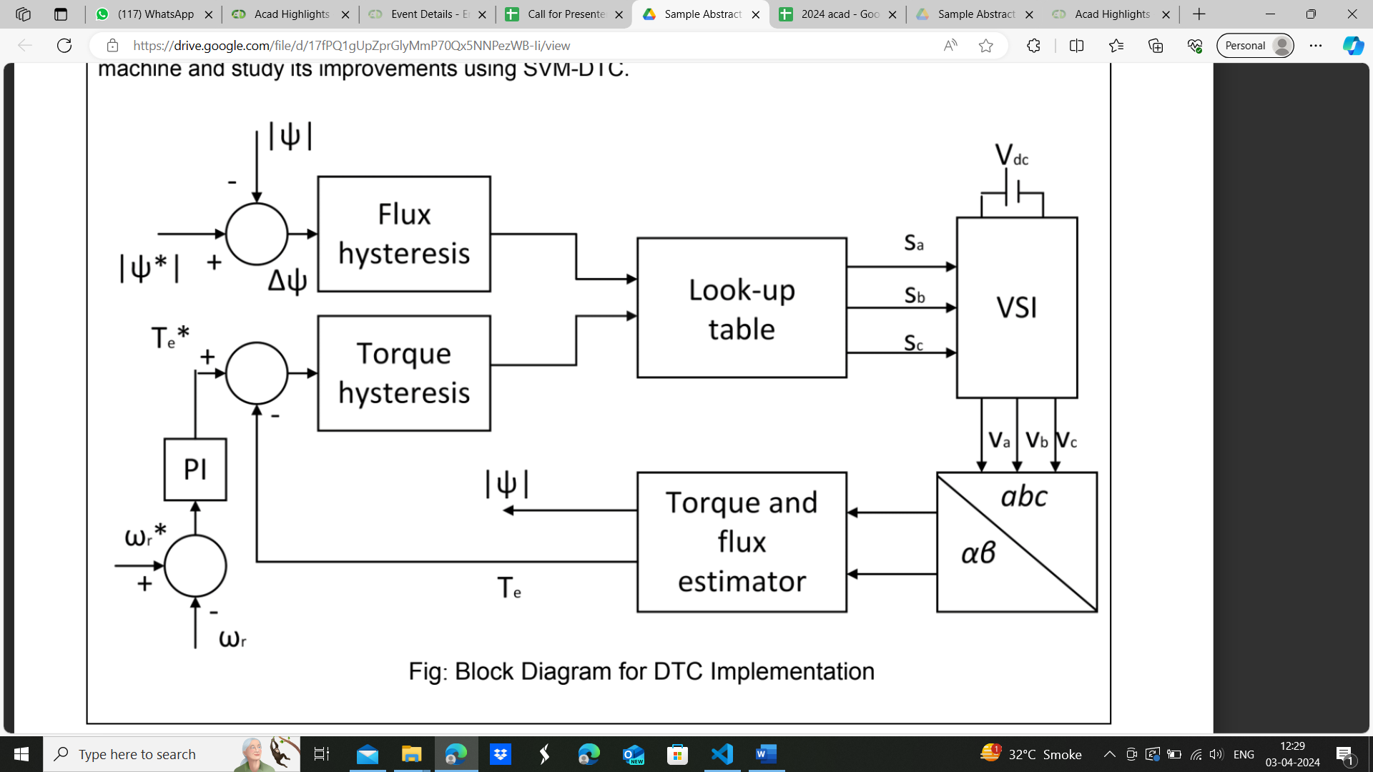

Figure 4 Block Diagram for DTC implementation

**Keywords:**

Electric drives, Induction machine, Motor control, Space-Vector Modulation

Induction motors (IM) are widely used due to their simple, rugged, and reliable construction. The control of IM speed can be broadly categorized into two types: scalar control and vector control. Scalar control is based on the steady-state relationship of the motor where the magnitude and frequency of

current and voltage can be controlled. On the other hand, vector control takes care of the transient and steady-state behavior of the machine using state space vectors. It can determine not only voltage and frequency but also the instantaneous value of quantities. Recently, more advanced control methods like Field-oriented control (FOC) and Direct torque control (DTC) have been developed and are widely used in industrial applications. However, FOC requires speed sensors and complex transformation algorithms for control. Conventional DTC schemes are used to directly control the torque and flux of inverter-fed induction motors. This project aims to demonstrate direct torque control on an induction machine and study its improvements using SVM-DTC.

* + 1. Design and development of a battery charger for electric vehicles

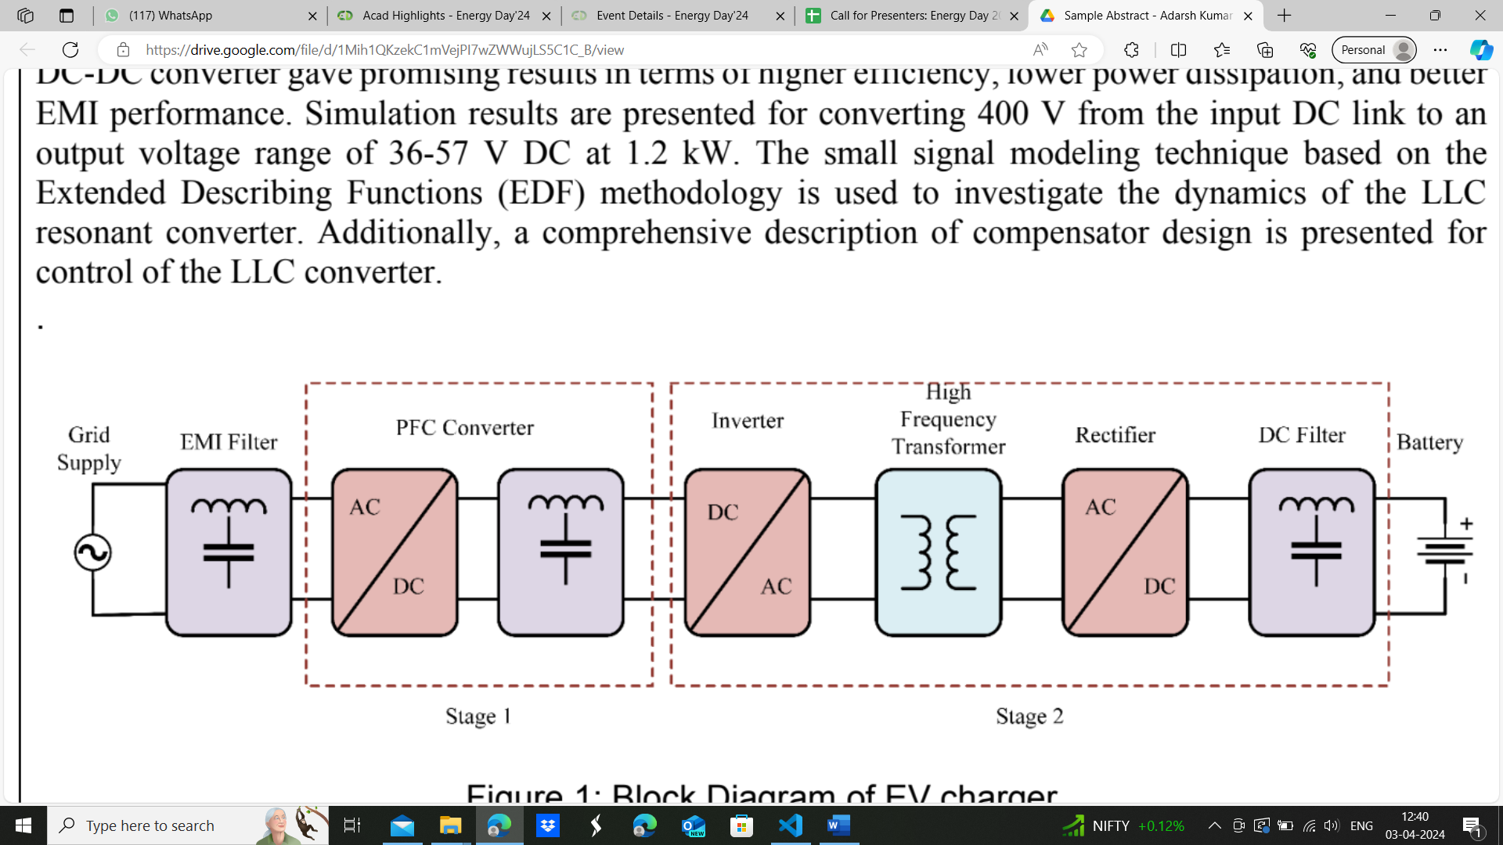

Figure 5 Block Diagram of EV charger

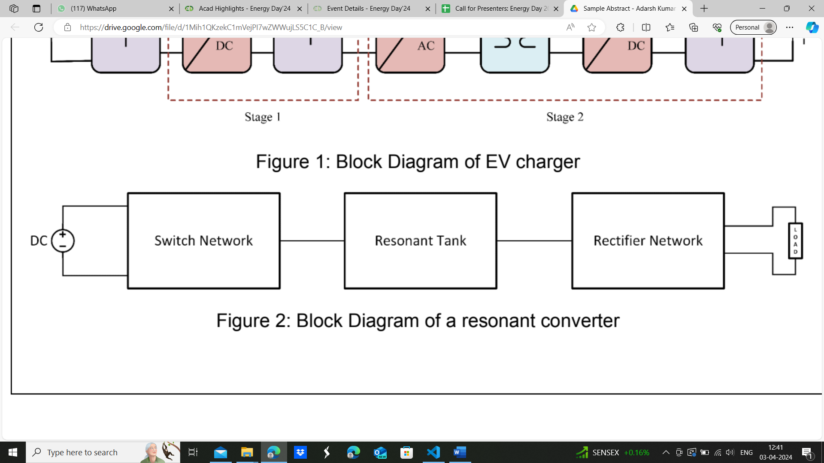

Figure 6 Block diagram of a Resonant Converter

**Keywords:**

Resonant Converter, LLC DC-DC Converter, Soft Switching, Small signal modeling, Switching losses

The rapid growth in electric vehicle (EV) adoption has prompted the need for efficient and reliable charging infrastructure to support the widespread deployment of electric mobility. This project focuses on the design and development of an EV charger on the basis of LLC resonant converter topology for EV applications. The power conversion topologies, such as resonant DC-DC converters with soft-switching techniques, are investigated to improve power efficiency and reduce switching losses. The LLC resonant DC-DC converter gave promising results in terms of higher efficiency, lower power dissipation, and better EMI performance. Simulation results are presented for converting 400 V from the input DC link to an output voltage range of 36-57 V DC at 1.2 kW. The small signal modelling technique based on the Extended Describing Functions (EDF) methodology is used to investigate the dynamics of the LLC resonant converter. Additionally, a comprehensive description of compensator design is presented for control of the LLC converter.

* + 1. Battery Charger for Electric Vehicle Applications

|  |  |  |  |  |  |  |  |  |  |  |  |  |  |  |  |
| --- | --- | --- | --- | --- | --- | --- | --- | --- | --- | --- | --- | --- | --- | --- | --- |
| 31/03/2024 19:50:08 | 19D170005@iitb.ac.in | Saahil Behere | 19D170005 | B.Tech. + M.Tech. | 5 |  | Battery Charger for Electric Vehicle Applications | Prof. Siddavatam Ravi Prakash Reddy | <https://drive.google.com/open?id=1ndwnp7Z3Ah4jn-U2ooyGyPWcavUry6hL> | [Saahil_Abstract - Behere Saahil Shashank.docx](https://drive.google.com/open?id=14aPXH1_TEKYY9Ygq9ikBzRBzflHcaA_u) | [DAB_diagram - Behere Saahil Shashank.png](https://drive.google.com/open?id=1ndwnp7Z3Ah4jn-U2ooyGyPWcavUry6hL) |  |  | [Saahil_Abstract - Behere Saahil Shashank.docx](https://drive.google.com/open?id=14aPXH1_TEKYY9Ygq9ikBzRBzflHcaA_u) | [DAB_diagram - Behere Saahil Shashank.png](https://drive.google.com/open?id=1ndwnp7Z3Ah4jn-U2ooyGyPWcavUry6hL) |

<https://drive.google.com/open?id=14aPXH1_TEKYY9Ygq9ikBzRBzflHcaA_u>

**Keywords:**

Electric Vehicles, Power Electronics, EV Charging, Soft Switching, Dual Active Bridge

With the need for cleaner technologies growing globally, the electric vehicle (EV) industry received an enormous boost, increasing global interest significantly. As EV adoption increases, the need for better charging topologies arises. Increasing the performance of modern EVs brings about weight and size constraints, which necessitate high efficiency and high power density chargers. One such topology involves a DC-DC Dual Active Bridge power converter, which achieves high efficiency through Zero Voltage turn-on, reducing switching loss significantly. Another application of this converter is in DC fast chargers, where converters are stacked in parallel to achieve high power. This study discusses the design and operation of a Dual Active Bridge converter in single phase-shift modulation, the impact of design variables on soft-switching range and hardware design for a 1kW system in open loop control.

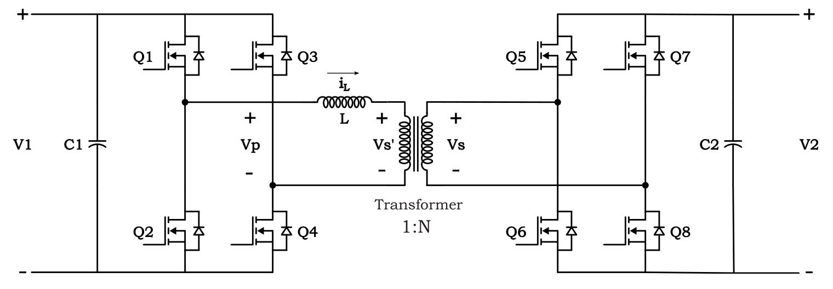

Figure 7 Dual Active Bridge Converter

* + 1. Development of smart charging solution for EV charging station

|  |  |  |  |  |  |  |  |  |  |  |  |  |  |  |  |
| --- | --- | --- | --- | --- | --- | --- | --- | --- | --- | --- | --- | --- | --- | --- | --- |
| 31/03/2024 13:35:43 | 22m1355@iitb.ac.in | rifqah ibrahim k | 22m1355 | M.Tech. | 2 | Energy Storage and Conversion Technologies | Development of smart charging solution for EV charging station | Prof. Zakir Hussain Rather | https://drive.google.com/open?id=1BUqfKen0mm71BPYCQLjS9Z5IYGEwqMDk, https://drive.google.com/open?id=1TitlXv8MZDQiqdvagLjycii0OZVOQxjz | [abstract - Rifqah Ibrahim K.pdf](https://drive.google.com/open?id=1BUqfKen0mm71BPYCQLjS9Z5IYGEwqMDk) | [Block diagram of EV charging station - rifqah ibrahim.JPG](https://drive.google.com/open?id=1TitlXv8MZDQiqdvagLjycii0OZVOQxjz) |  |  | [abstract - Rifqah Ibrahim K.pdf](https://drive.google.com/open?id=1BUqfKen0mm71BPYCQLjS9Z5IYGEwqMDk) | [Block diagram of EV charging station - rifqah ibrahim.JPG](https://drive.google.com/open?id=1TitlXv8MZDQiqdvagLjycii0OZVOQxjz) |

Keywords: Electric vehicles (EVs), Renewable energy integration, CO2 emissions reduction,Smart grid technology, Photovoltaic (PV) charging station, Grid independence, Smart charging algorithm

The electricity and transportation sectors contribute to majority of the total global carbon dioxide (CO2) emissions, posing an escalating environmental challenge. To address this issue effectively, the adoption of electric vehicles (EVs) and renewable energy sources offers a promising solution to significantly decrease emissions from transportation and power generation. However, to maximize environmental and economic advantages, integrating EVs and renewable energy sources within a smart grid infrastructure is essential. One possible strategy to reduce CO2 emissions is to use renewable energy as a complete or partial source of power for EV charging

stations (CSs). This project introduces a novel approach by designing a photovoltaic (PV)-based charging station that aims for independence from the grid. Leveraging smart charging technologies and incorporating vehicle-to-grid (V2G) capabilities, the charging station offers a sustainable and cost-effective solution for EV owners and charging station operators alike. Key

components of the project include the PV system for renewable energy generation, intelligent charging algorithms to optimize charging schedules and minimize operating costs, and V2G functionality allowing EVs to feed surplus energy back to the grid during peak demand periods.

The integration of these technologies not only reduces the environmental footprint of EV charging but also contributes to grid stability and resilience.

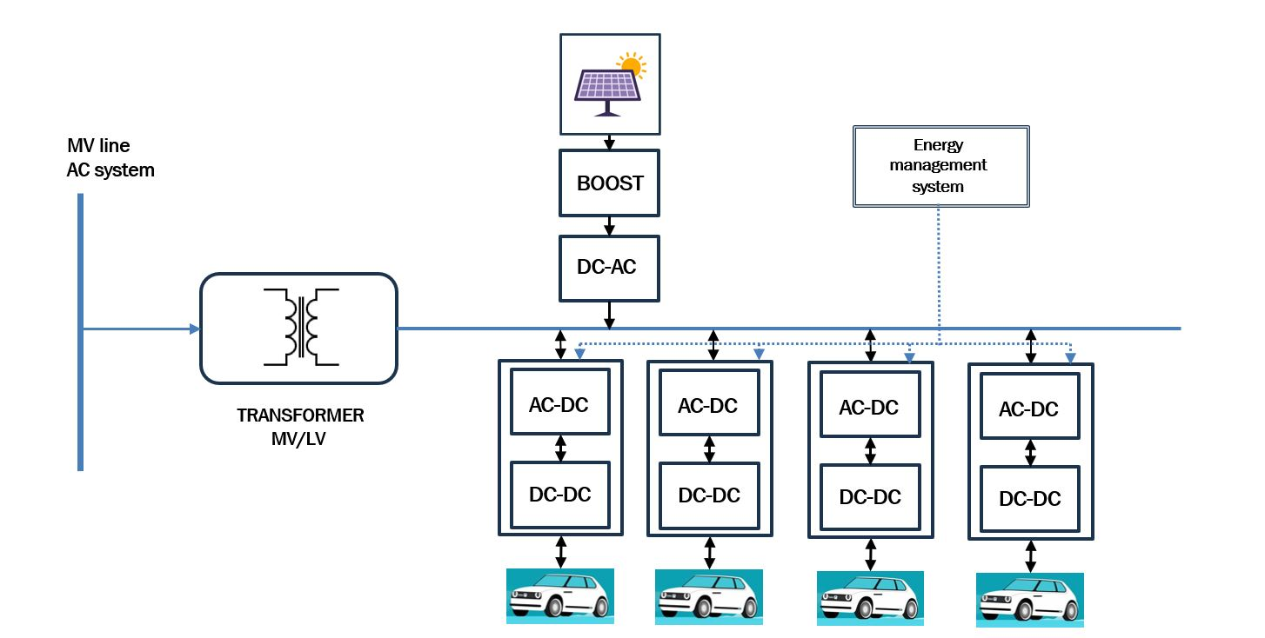

* + 1. Field-Oriented Control of Permanent Magnet Synchronous Machine for Electric Vehicles

|  |  |  |  |  |  |  |  |  |  |  |  |  |  |  |
| --- | --- | --- | --- | --- | --- | --- | --- | --- | --- | --- | --- | --- | --- | --- |
| 31/03/2024 00:01:35 | 22m1361@iitb.ac.in | Ajay Kumbar | 22M1361 | M.Tech. | 2 |  | : Field-Oriented Control of Permanent Magnet Synchronous Machine for Electric Vehicles | Prof. S Ravi Prakash Reddy | https://drive.google.com/open?id=1C9CimNcpPbIhI4j-WGjyITjzZeIMkfdz | [Abstract for energy day - Ajay Kumbar.pdf](https://drive.google.com/open?id=1C9CimNcpPbIhI4j-WGjyITjzZeIMkfdz) |  |  |  | [Abstract for energy day - Ajay Kumbar.pdf](https://drive.google.com/open?id=1C9CimNcpPbIhI4j-WGjyITjzZeIMkfdz) |

**Keywords:** IPMSM, FOC, Synchronous reference frame, Current sensing Techniques

Permanent magnet synchronous machines(PMSM) are the most preferred machines in the  present world. It finds applications in electric vehicles(EVs), industrial pumps etc., due to its numerous  advantages including high efficiency, high power density and high torque to inertia ratio. In applications like EVs precise and accurate control of machine becomes very important for high-performance control  of PMSM drives. Field-oriented control (FOC) is one of the high-performance control schemes, that provides independent control of torque and flux, by decoupling flux and torque. In motor control techniques, FOC has become a conventional method nowadays. This project deals with FOC for interior permanent magnet synchronous machine with shunt resistor-based current sensing techniques. The study begins with modelling of the IPMSM in synchronously rotating reference frame(d-q frame). A closed loop control has been developed to control speed and torque. The FOC is implemented and simulated with the designed controls. The current measurement is important factor for working of FOC so in this project different shunt based current sensing techniques will be studied.

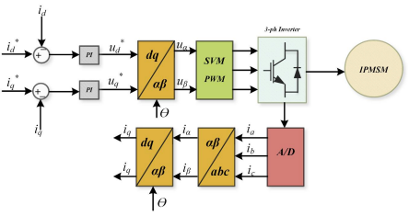

Figure 8 Field Oriented Control Scheme of IPMSM

* + 1. Blackstart Capability of Grid Forming Inverter based Solar PV Power Plants

|  |  |  |  |  |  |  |  |  |  |  |  |  |  |  |  |
| --- | --- | --- | --- | --- | --- | --- | --- | --- | --- | --- | --- | --- | --- | --- | --- |
| 31/03/2024 18:52:46 | 22m1354@iitb.ac.in | Rashmi Rajendra Keche | 22M1354 | M.Tech. | 2 | Power Electronics and Smart Grids | Blackstart Capability of Grid Forming Inverter based Solar PV Power Plants | Prof. Zakir Hussain Rather | https://drive.google.com/open?id=1dmUP4hj5Cc15GMZ6d6ChBwSulgTuS9vd, https://drive.google.com/open?id=1IaitYfHjkaIzTzV8BQg3oIewVxFohUPX, https://drive.google.com/open?id=1y6U3Wyipdb9W5sZw4Y5hO85dBhWg88W5 | [Abstract_Rashmi - Rashmi Keche.pdf](https://drive.google.com/open?id=1dmUP4hj5Cc15GMZ6d6ChBwSulgTuS9vd) | [Abstract_22M1354_Rashmi - Rashmi Keche.pdf](https://drive.google.com/open?id=1IaitYfHjkaIzTzV8BQg3oIewVxFohUPX) | [Abstract_image_22M1354_Rashmi - Rashmi Keche.pdf](https://drive.google.com/open?id=1y6U3Wyipdb9W5sZw4Y5hO85dBhWg88W5) |  | [Abstract_22M1354_Rashmi - Rashmi Keche.pdf](https://drive.google.com/open?id=1IaitYfHjkaIzTzV8BQg3oIewVxFohUPX) | [Abstract_image_22M1354_Rashmi - Rashmi Keche.pdf](https://drive.google.com/open?id=1y6U3Wyipdb9W5sZw4Y5hO85dBhWg88W5) |

**Key words:** Grid forming inverter (GFMIs), Grid following inverters (GFLIs),  Solar PV, Blackstart, Virtual synchronous machine (VSM)

The rise of renewable energy sources like wind and solar is leading to more inverter  based generation in power systems, causing stability concerns due to the lack of inherent inertia in inverters. Grid-forming inverters (GFMIs) have emerged as a  solution, capable of regulating voltage and frequency unlike grid-following inverters  (GFLIs). With the increasing integration of solar photovoltaics (PVs), there is a  growing interest in assessing their potential to support the grid. Blackouts are the  events that disrupt the system, and restoring it is challenging. Traditionally, hydro  and gas turbine provides the black start capability, but as power systems shift  towards renewables, such as PV plants, their role in power system restoration  becomes vital. Efforts are underway to maximize the effectiveness of solar energy,  including its black start support capability, highlighting its significance in ensuring  power system resilience and reliability using GFMIs. This project introduces a  Blackstart capability of large scale solar PV plants using Virtual synchronous  machine (VSM) control of a GFMIs.

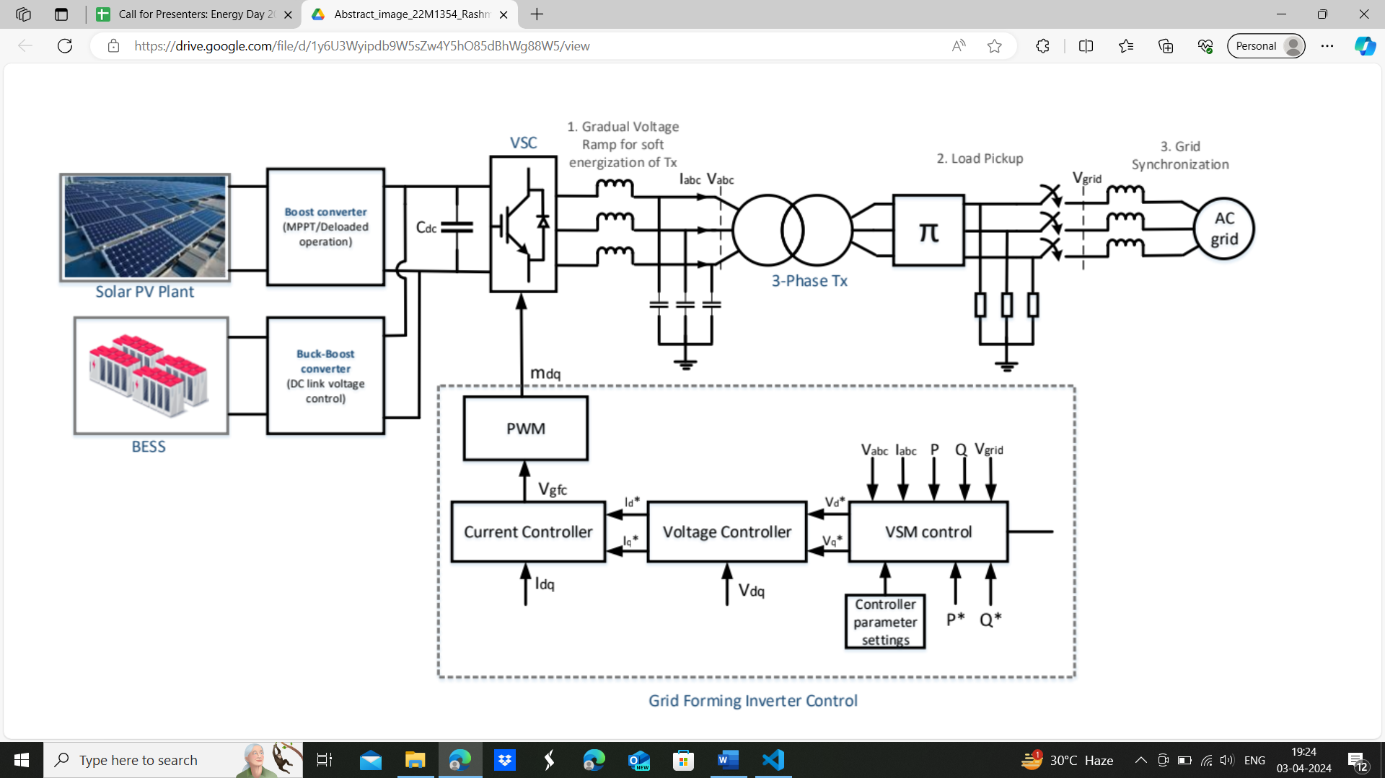

* + 1. Unbalance Mitigation and Neutral Current Suppression in Distribution Networks using 3 Phase-4 Leg Grid Forming Inverter

|  |  |  |  |  |  |  |  |  |  |  |  |  |  |  |  |
| --- | --- | --- | --- | --- | --- | --- | --- | --- | --- | --- | --- | --- | --- | --- | --- |
| 30/03/2024 23:00:34 | vedantchandak@iitb.ac.in | Vedant Chandak | 19D170034 | B.Tech. + M.Tech. | 5 | Power Electronics and Smart Grids | Unbalance Mitigation and Neutral Current Suppression in Distribution Networks using 3 Phase-4 Leg Grid Forming Inverter | Prof. Suryanarayana Doolla | https://drive.google.com/open?id=1wiuRuj4dHSF6hwGrdIV0QeCwP04H4a54, https://drive.google.com/open?id=1UPP22FKWZXZ2SsenbiIt7CFNmIOTzZ6P | [Abstract for Energy Day - Vedant Vinod Chandak.pdf](https://drive.google.com/open?id=1UPP22FKWZXZ2SsenbiIt7CFNmIOTzZ6P) | [3 phase 4 leg converter - Vedant Vinod Chandak.png](https://drive.google.com/open?id=1wiuRuj4dHSF6hwGrdIV0QeCwP04H4a54) |  |  | [Abstract for Energy Day - Vedant Vinod Chandak.pdf](https://drive.google.com/open?id=1UPP22FKWZXZ2SsenbiIt7CFNmIOTzZ6P) | [3 phase 4 leg converter - Vedant Vinod Chandak.png](https://drive.google.com/open?id=1wiuRuj4dHSF6hwGrdIV0QeCwP04H4a54) |

**Keywords:**

Grid Forming Inverter, Unbalance Mitigation, Voltage Unbalance Factor, Neutral current

This study investigates the challenges posed by unbalanced loads in distribution networks and proposes a novel approach for mitigating unbalance and suppressing neutral currents using a three-phase four-leg grid-forming inverter. Unbalance in distribution networks arises from the presence of various single-phase loads dispersed throughout the system. The proposed method employs adaptive adjustments to voltage references to effectively suppress current imbalances while ensuring that the voltage unbalance factor remains within acceptable limits. By integrating advanced control strategies within the grid-forming inverter, the research aims to enhance the stability and efficiency of distribution networks, thereby contributing to the overall reliability and performance of the electrical power system. The findings of this study offer valuable insights into addressing the challenges associated with unbalanced loads in distribution networks, providing a pathway towards more resilient and sustainable power distribution infrastructures.

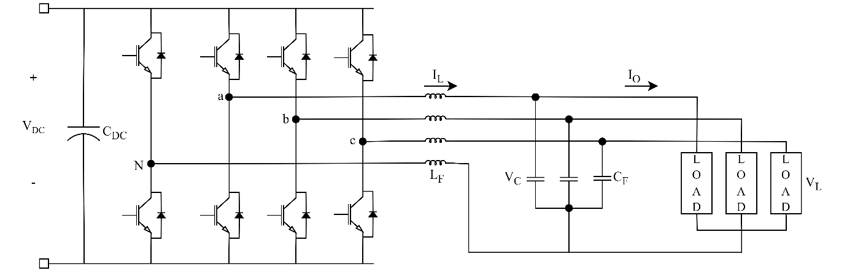

Figure 9 3 Phase 4 leg power electronic converter

* + 1. Vehicle to Grid (V2G) Support Services

|  |  |  |  |  |  |  |  |  |  |  |  |  |  |  |  |
| --- | --- | --- | --- | --- | --- | --- | --- | --- | --- | --- | --- | --- | --- | --- | --- |
| 30/03/2024 22:25:43 | 22m1356@iitb.ac.in | A SAIKEERTHI | 22M1356 | M.Tech. | 2 | Power Electronics and Smart Grids | Vehicle to Grid (V2G) Support Services | Prof. Zakir Hussain Rather | https://drive.google.com/open?id=1cuVcroXo7DBexJCwKcgjwsrVWsrd2R66, https://drive.google.com/open?id=115jHuW8Lhy6Sr4Xd8zyRHnk-dmZiX1Yo | [Abstract_Energy Day_22m1356 - A Saikeerthi.pdf](https://drive.google.com/open?id=115jHuW8Lhy6Sr4Xd8zyRHnk-dmZiX1Yo) | [pic_freq_regulation - A Saikeerthi.png](https://drive.google.com/open?id=1cuVcroXo7DBexJCwKcgjwsrVWsrd2R66) |  |  | [Abstract_Energy Day_22m1356 - A Saikeerthi.pdf](https://drive.google.com/open?id=115jHuW8Lhy6Sr4Xd8zyRHnk-dmZiX1Yo) | [pic_freq_regulation - A Saikeerthi.png](https://drive.google.com/open?id=1cuVcroXo7DBexJCwKcgjwsrVWsrd2R66) |

**Keywords:** Electric Vehicles (EVs), Vehicle-to-Grid (V2G), Bidirectional chargers, Ancillary  services, Frequency Regulation.

With growing pollution levels from the transportation sector and increased environmental concerns, a transition from fossil fuel vehicles to electric vehicles is being empowered globally.  As electric vehicles (EVs) become increasingly prevalent, a novel concept known as Vehicle to-Grid (V2G) has emerged, promising to revolutionize the energy landscape. V2G support services involve bi-directional power flow, allowing EV batteries to not only draw electricity from the grid but also to inject power back into the grid when required. Vehicle-to-Grid support services represent a promising and innovative solution for sustainable energy integration and grid stability. The study focuses on modelling EV charger to meet specific power requirements and outlines the charging management system for four CHAdeMO chargers. The analysis of the obtained results aims to validate the facilitation of bidirectional power flow using Power Hardware-in-the-Loop (PHIL) by effectively controlling current in both G2V and V2G modes. V2G control has the potential to offer frequency regulation services for power system operation through EVs. A smart charging method, known as charging with frequency regulation (CFR), has been developed to enable scheduled charging while simultaneously providing frequency regulation. A simulation study is conducted on the IEEE 9 bus system to demonstrate the effectiveness of the proposed CFR method.

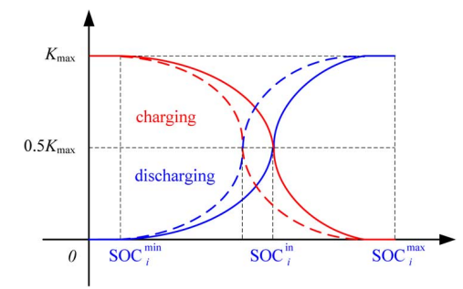

Figure 10 Adaptive drop of the BSH for maintaining the initial SOC

* + 1. Blackstart and Restoration of Distribution System in the Presence of Distributed Generators

|  |  |  |  |  |  |  |  |  |  |  |  |  |  |  |  |
| --- | --- | --- | --- | --- | --- | --- | --- | --- | --- | --- | --- | --- | --- | --- | --- |
| 30/03/2024 12:10:06 | diptiman_dey@iitb.ac.in | Diptiman Dey | 204170004 | Ph.D | 4 | Power Electronics and Smart Grids | Blackstart and Restoration of Distribution System in the Presence of Distributed Generators | Suryanarayana Doolla | https://drive.google.com/open?id=1OOIJa12DA3KCgpf71zwjGAEMLmHWpt2O, https://drive.google.com/open?id=1fGON_R_MVwxX4NuIkWgozolwPWAEmhDl | [Abstract - Diptiman Dey.docx](https://drive.google.com/open?id=1OOIJa12DA3KCgpf71zwjGAEMLmHWpt2O) | [Bottom to top - Diptiman Dey.png](https://drive.google.com/open?id=1fGON_R_MVwxX4NuIkWgozolwPWAEmhDl) |  |  | [Abstract - Diptiman Dey.docx](https://drive.google.com/open?id=1OOIJa12DA3KCgpf71zwjGAEMLmHWpt2O) | [Bottom to top - Diptiman Dey.png](https://drive.google.com/open?id=1fGON_R_MVwxX4NuIkWgozolwPWAEmhDl) |

Keywords: Blackstart, blackout, cold load pick up, grid-forming converter, grid outage, intelligent electronic device, re-synchronization

Restoring power system after an outage involves reconnecting and re-synchronizing power islands due to presence of renewable rich systems, which can cause high transient currents and result in circuit breaker tripping, ultimately reducing grid resiliency. One effective way to address this issue is by minimizing inrush currents during cold load pickup, which is particularly crucial during blackstart events, especially in systems with high renewable energy integration. This research paper proposes a bottom-to-top approach for restoring and re-synchronizing a large distribution network comprising multiple small power islands. The proposed approach is evaluated using a modified IEEE 33-bus system equipped with four renewable distributed generators. Results demonstrate a significant reduction in inrush current during the restoration process using the proposed technique, which complies with the re-connection standards outlined in IEEE-1547. This reduction in inrush currents contributes to improved grid resiliency. The effectiveness of the algorithm is further validated using software in loop in real-time through the development of a test bed utilizing Opal-RT.

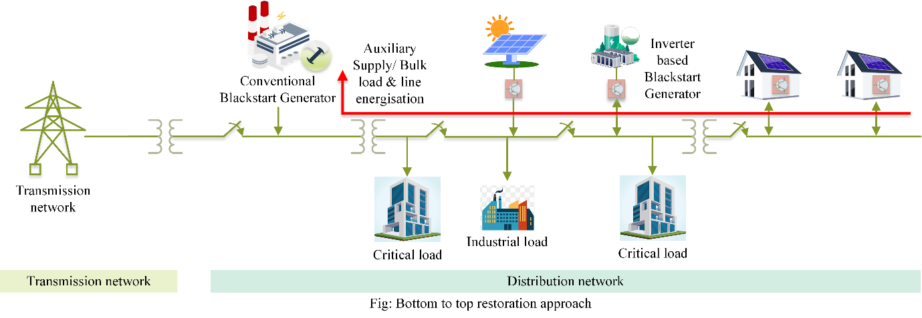

Figure 11 Bottom to top restoration approach

* + 1. Non-linear virtual impedance shaping strategy for predominantly resistive islanded power networks

|  |  |  |  |  |  |  |  |  |  |  |  |  |  |  |  |
| --- | --- | --- | --- | --- | --- | --- | --- | --- | --- | --- | --- | --- | --- | --- | --- |
| 29/03/2024 13:24:42 | salildubey@iitb.ac.in | Salil Madhav Dubey | 204176001 | Ph.D | 4 | Power Electronics and Smart Grids | Non-linear virtual impedance shaping strategy for predominantly resistive islanded power networks | Suryanarayana Doolla | https://drive.google.com/open?id=1jlPhIT2bimm1qS3hzL7URGS2Vn5Q-SwH | [Abstract - SALIL DUBEY.pdf](https://drive.google.com/open?id=1jlPhIT2bimm1qS3hzL7URGS2Vn5Q-SwH) |  |  |  | [Abstract - SALIL DUBEY.pdf](https://drive.google.com/open?id=1jlPhIT2bimm1qS3hzL7URGS2Vn5Q-SwH) |  |

Keywords: Impedance-based-droop, Non-linear droop, Renewable integration, Inverse droop

control, Power sharing, Virtual impedance, Negative Sequence

**Abstract:** In contemporary distribution networks, converter-based distributed generators (DGs) are increasingly utilized to harness power from renewable sources. A prominent challenge in employing decentralized control for this purpose is the inaccurate distribution of real power among these DGs due to voltage drops caused by feeder/line impedances. To address this issue, many turn to employing virtual voltage drop within the controllers of these DGs, which helps mitigate impedance mismatches and improves power sharing. However, determining the appropriate value for this virtual voltage drop presents a significant challenge. This paper delves into a droop-based VI shaping technique tailored for converter-based DGs, particularly focusing on nonlinear variations for predominantly resistive islanded networks.  The effectiveness of this technique is evaluated across a broad spectrum of loads, encompassing balanced (constant impedance), constant power, unbalanced, nonlinear, and induction motor loads, through comprehensive simulations. Furthermore, the proposed method is tested in a mesh network setting. The performance of DG plug-and-play functionality and the impact of load variations are examined on a modified 13-bus network using the proposed control scheme.  The stability range for control parameters is validated through modelling and eigenvalue analysis. Experimental validation on a laboratory setup further corroborates the efficacy of the proposed strategy. Additionally, the technique is extended to achieve closer-to-proportional sharing of unbalanced currents, enhancing its applicability in diverse scenarios.

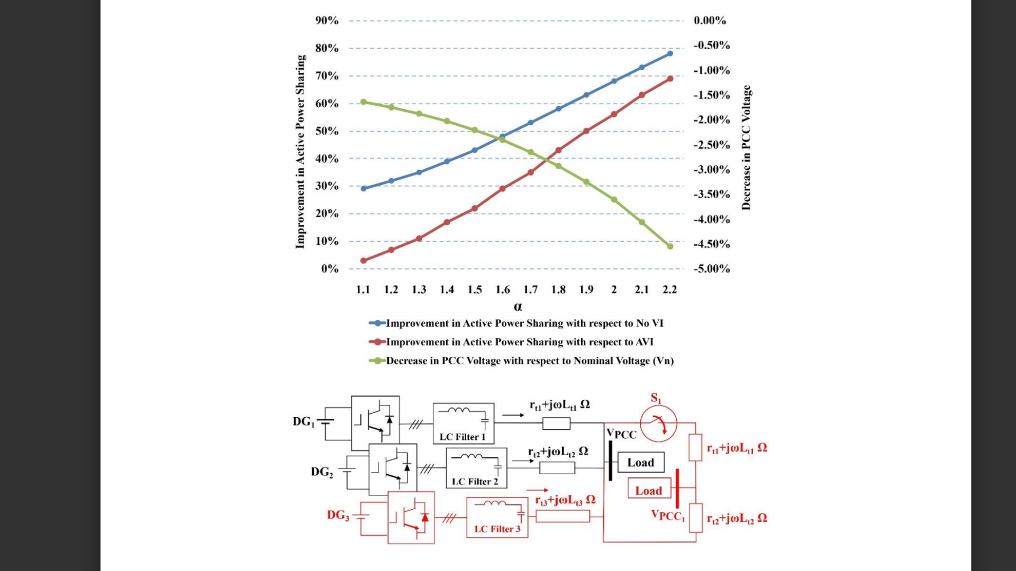

* + 1. Development of 4-Quadrant Power Amplifier for Power Hardware-in-the-Loop Validations

|  |  |  |  |  |  |  |  |  |  |  |  |  |  |  |  |
| --- | --- | --- | --- | --- | --- | --- | --- | --- | --- | --- | --- | --- | --- | --- | --- |
| 25/03/2024 23:03:12 | 22m1348@iitb.ac.in | K P Vineeth | 22M1348 | M.Tech. | 2 | Power Electronics and Smart Grids | Development of 4-Quadrant Power Amplifier for Power Hardware-in-the-Loop Validations | Prof. Suryanarayana Doolla | https://drive.google.com/open?id=1V5Mwuj1grABj9rzUHe7qFn2OvqBYO0pS, https://drive.google.com/open?id=1eQ3xzdqNcnEm43L97GMdiMVfaGmj41Vg | [energy_day_abstract - Vineeth K P.pdf](https://drive.google.com/open?id=1V5Mwuj1grABj9rzUHe7qFn2OvqBYO0pS) | [PHIL_workflow - Vineeth K P.png](https://drive.google.com/open?id=1eQ3xzdqNcnEm43L97GMdiMVfaGmj41Vg) |  |  | [energy_day_abstract - Vineeth K P.pdf](https://drive.google.com/open?id=1V5Mwuj1grABj9rzUHe7qFn2OvqBYO0pS) | [PHIL_workflow - Vineeth K P.png](https://drive.google.com/open?id=1eQ3xzdqNcnEm43L97GMdiMVfaGmj41Vg) |

**Keywords**

PHIL, power amplifier, bidirectional converter, advanced control

Power Hardware-in-the-Loop (PHIL) can be used as a powerful tool for testing and validation of hardware before being deployed in the field since full-fledged hardware testing may not be feasible in a lab environment. PHIL provides a balance between cost and fidelity and can have an important role in renewable energy integration. The power amplifier is one of the main components which facilitates these tests. Commercially available power amplifiers are black boxes in terms of the control strategies implemented, which can lead to uncertainty in test results and unstable operation. Thus, it becomes necessary to develop a robust, dynamic and efficient power amplifier. The present work aims to develop and implement control strategies to operate a power electronics based bidirectional converter as a power amplifier with robust tracking and higher bandwidth when compared to conventional controls.

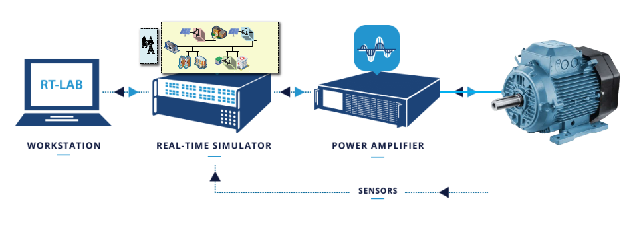

Figure 12 Typical PHIL test scheme

* + 1. Xii. Investigating the DC link dynamics of grid-connected inverters

|  |  |  |  |  |  |  |  |  |  |  |  |  |  |  |  |
| --- | --- | --- | --- | --- | --- | --- | --- | --- | --- | --- | --- | --- | --- | --- | --- |
| 25/03/2024 20:07:48 | 22m1351@iitb.ac.in | Kanishka Ravi Madishetty | 22M1351 | M.Tech. | 2 | Power Electronics and Smart Grids | Investigating the DC link dynamics of grid-connected inverters | Prof. Suryanarayana Doolla | https://drive.google.com/open?id=1oNodPdeBLZf0AzpDdu5V4b98PpiCrZZU, https://drive.google.com/open?id=1WLM4VJZzpsEBIT1VyHOuUKWPhYTX5GbR | [energy day abstract - Kanishka Ravi Madishetty.pdf](https://drive.google.com/open?id=1oNodPdeBLZf0AzpDdu5V4b98PpiCrZZU) | [SEAMLESS - Kanishka Ravi Madishetty.png](https://drive.google.com/open?id=1WLM4VJZzpsEBIT1VyHOuUKWPhYTX5GbR) |  |  | [energy day abstract - Kanishka Ravi Madishetty.pdf](https://drive.google.com/open?id=1oNodPdeBLZf0AzpDdu5V4b98PpiCrZZU) | [SEAMLESS - Kanishka Ravi Madishetty.png](https://drive.google.com/open?id=1WLM4VJZzpsEBIT1VyHOuUKWPhYTX5GbR) |

**Keywords:**

Distributed generation, Grid-forming, DC side dynamics, DC link control.

Integration of distributed generation (DG) has seen an exponential rise thanks to the presence  of renewable sources. Most DGs employ a two-stage topology to transmit the generated power  to the grid or feed its local loads. In most of the literature, strategies for the grid-forming  operation of a single DG or parallel DG operation have been developed, considering a stiff DC  source. However, due to intermittencies in renewables and limited reserves from storage, a stiff  DC source cannot be guaranteed. Thus, it would be evident to consider the non-stiff nature of  DC sources to imitate a much more practical study. To ensure a stable operation on the AC  side of the grid-connected system, it must be guaranteed that the DC side dynamics are well  within bounds. This project focuses on maintaining a stiff DC link using a PI-based control  strategy with sources on the DC side, such as PV and battery, working in coordination to  achieve the desired control objective while preserving a stable operation during normal and  during faults.

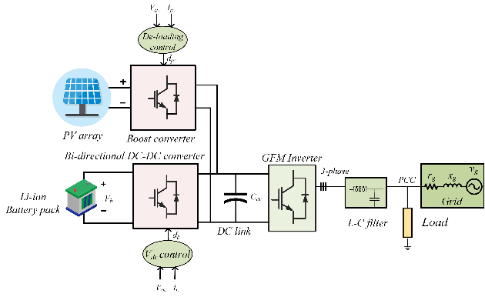

Figure 13 System Architecture

* + 1. Harmonic Analysis of Grid Connected Solar PV System

|  |  |  |  |  |  |  |  |  |
| --- | --- | --- | --- | --- | --- | --- | --- | --- |
| 04/04/2024 23:16:52 | roshanmkabeer@gmail.com | Roshan Mujeeb | 19D170024 | B.Tech. + M.Tech. | 5 | Harmonic Analysis of Grid Connected Solar PV System | Rajesh Gupta | <https://drive.google.com/open?id=1FU-xFol5G2TLhrCikm69kVYOBXuE9EIh> |

**Keywords:**

Power Quality, Harmonic, Grid Connected, Solar PV, Irradiance

**Abstract:**

In an era of rapid renewable energy integration, grid-connected photovoltaic (PV) systems have become a vital source of clean electricity. However, their seamless operation within the electrical grid necessitates a meticulous analysis of power quality. Variations in solar irradiation and temperature can significantly impact the performance of grid connected PV systems, leading to potential power quality issues. To address these concerns, this study embarked on a rigorous literature review, delving into existing research on the impact of irradiation and temperature fluctuations on power quality in grid connected PV systems.

The study progressed to the design and simulation of a three-phase grid-connected PV system using MATLAB Simulink. This hands-on approach allowed for the assessment of real-world scenarios, offering valuable insights into the system's power quality characteristics. The simulation results reveal critical insights into the behaviour of the grid-connected PV system under the influence of varying irradiance and temperature.

## C. Advanced Combustion and Energy Conversion Technologies

* + 1. Cogasification of biomass and plastic wastes

|  |  |  |  |  |  |  |  |  |  |  |  |  |  |  |
| --- | --- | --- | --- | --- | --- | --- | --- | --- | --- | --- | --- | --- | --- | --- |
| 29/03/2024 21:23:46 | nishant.ranjan@iitb.ac.in | Nishant Ranjan | 194170001 | Ph.D | 5 | Renewable Energy and Sustainability | Cogasification of biomass and plastic wastes | Prof. Sandeep Kumar | https://drive.google.com/open?id=1pzHny3jaxlrtjIqOsslY_zB0juNjkP-I | [Energy Day abstract_2024_Nishant - NISHANT RANJAN.docx](https://drive.google.com/open?id=1pzHny3jaxlrtjIqOsslY_zB0juNjkP-I) |  |  |  | [Energy Day abstract_2024_Nishant - NISHANT RANJAN.docx](https://drive.google.com/open?id=1pzHny3jaxlrtjIqOsslY_zB0juNjkP-I) |

**Keywords:** Biomass; Plastic wastes, Co-pelletisation

As the issues of energy security and waste management worsen, it is imperative to use renewable energy resources along with wastes with calorific values, viz. biomass and plastic wastes, for the benefits of energy extraction and waste management. Pelletisation, as a feed densification strategy, is an important aspect for uniformity in the feed properties and increased bulk density for efficient usage in thermochemical energy harnessing such as combustion, incineration, gasification, etc.

In the present study, the co-pelletisation of biomass and plastic wastes has been investigated. Poor adhesion between biomass and plastics necessitates use of additional binders or preheating of the feeds. Hence, in the present study, wheat flour has been used as a binder and the plastic content in the feed was changed from 0 to 30 % with a step of 5 %. The influence of plastic addition on the pelletisation performance parameters has been analysed. The increase in feed plastic content adversely affected pellet durability and hardness. However, favourable pelletisation was obtained up to feed plastic content of 25 % such that durability and hardness values were greater than 96 % and 22 kgf, respectively. The calculated and measured pellet gross calorific values were also in close agreement.

* + 1. Bifurcation Analysis of Natural Circulation Loop

**Keywords:**  Natural circulation loop, heat transfer, stability analysis, pressure drop vs flow rate

A detailed analysis of the natural circulation loop has been carried out by analyzing the pressure drop vs mass flow rate curve. The pressure drop vs mass flow rate curve shows the behavior of two-phase flow in a heated section against inlet velocity at a steady state. The different pressure drop components including gravitation pressure drop, pressure drop due to change in cross-section, single-phase frictional pressure drops and two-phase frictional pressure have been shown separately along with the final N-shaped curve. It has also been found that multiple solutions for the system don’t exist for all the values of the parameter. A parametric effect on the shape and nature of the curve has been analysed by variation power (*Npch*), subcooling (*Nsub*), heated section diameter, and height. The range of existence of multiple solutions has also been obtained by analysing the N-shaped curve for different parametric values.

* + 1. Hydrogen production by Catalytic upgradation of syngas obtained through oxy-steam Gasification of waste biomass.

|  |  |  |  |  |  |  |  |  |  |  |  |  |  |  |  |
| --- | --- | --- | --- | --- | --- | --- | --- | --- | --- | --- | --- | --- | --- | --- | --- |
| 01/04/2024 10:42:08 | 22m1347@iitb.ac.in | Yash Nareshkumar Jariwala | 22M1347 | M.Tech. | 2 |  | Hydrogen production by Catalytic upgradation of syngas obtained through oxy-steam Gasification of waste biomass. | Prof. Sandeep Kumar | https://drive.google.com/open?id=10y10NNI_1iZBT5Do-08D_tZ3MF2JSUEJ, https://drive.google.com/open?id=1l3w41vFpIJhKhpgU35l_klXOm3yiht_T | [Energy Day 2024 Abstract - Yash Nareshkumar Jariwala.docx](https://drive.google.com/open?id=10y10NNI_1iZBT5Do-08D_tZ3MF2JSUEJ) | [Energy Day 2024 Abstract_Latest - Yash Jariwala.docx](https://drive.google.com/open?id=1l3w41vFpIJhKhpgU35l_klXOm3yiht_T) |  |  | [Energy Day 2024 Abstract_Latest - Yash Jariwala.docx](https://drive.google.com/open?id=1l3w41vFpIJhKhpgU35l_klXOm3yiht_T) |  |

**Keywords:** Sustainable H2 Production, Novel-Catalyst, Biomass Gasification, Waste to Energy

In the current era we are facing the pressing issue of climate change resulting from the CO2 emission from fossil fuel burning. Researchers identified Hydrogen as a clean fuel and energy carrier for today’s need. Among many technologies, the biomass gasification is a promising one for generating clean energy and valuable chemicals from bio-waste. Specifically, the focus is on oxy-steam gasification; it gives higher hydrogen yield and higher calorific value Syngas.  Some preliminary calculation suggests that oxy-steam gasification with lower steam to biomass ratio (SBR) and externally converting CO + H2O to CO2 + H2 in water gas shift reactor is more economical and efficient than the one with only higher SBR for getting higher Hydrogen yield. The earlier high temperature water gas shift (HT-WGS) catalyst, Fe2O3-Cr2O3 was proven to be hazardous due to carcinogenic Cr+6. The novel Cr-free catalysts, Fe/Al/Cu oxides (wt. % - 83/7/10) was proven to be active, thermally stable, and efficient; it can potentially replace the earlier HT-WGS catalyst. Current study involves the effect of doping Ca and Ce in FAC catalyst for further improvement. The ongoing work includes developing these catalysts, their characterization, and determining it’s activity for water gas shift reaction.

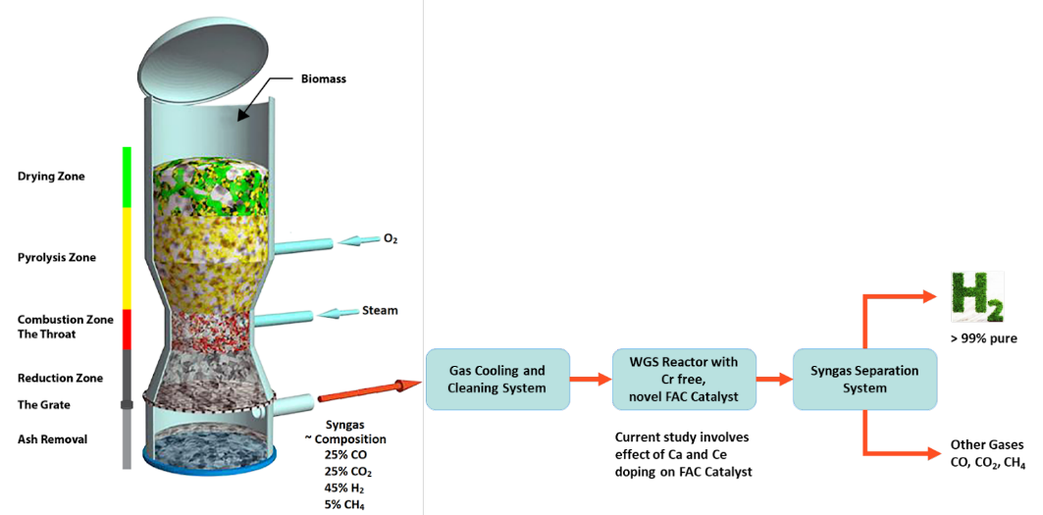

* + 1. Comparative Techno-Economic Analysis and Carbon Footprint Evaluation of Hydrogen Fuel Cell Vehicles versus Battery Electric Vehicles

|  |  |  |  |  |  |  |  |  |  |  |  |
| --- | --- | --- | --- | --- | --- | --- | --- | --- | --- | --- | --- |
| 31/03/2024 17:38:05 | bsrushti25@gmail.com | Srushti Bhamare | 19D170006 | B.Tech. + M.Tech. | 5 |  | Comparative Techno-Economic Analysis and Carbon Footprint Evaluation of Hydrogen Fuel Cell Vehicles versus Battery Electric Vehicles | Prof. Pratibha Sharma | https://drive.google.com/open?id=1PqU8nYAIOL2mRK9kYzr0O0k3CNcXwuGw, https://drive.google.com/open?id=1DDGE1-te9_a67oMVSP9gO0qWUxQ3hDHc | [Abstract - Energy Day Srushti - 19D170006 - Srushti Bhamare.docx](https://drive.google.com/open?id=1PqU8nYAIOL2mRK9kYzr0O0k3CNcXwuGw) | [Abstract - Srushti - Srushti Bhamare.jpg](https://drive.google.com/open?id=1DDGE1-te9_a67oMVSP9gO0qWUxQ3hDHc) |

**Keywords:** Hydrogen Fuel cell vehicles, Life cycle analysis, Energy analysis

The transportation sector is a significant contributor which is nearly 20% of global carbon dioxide emissions, necessitating the adoption of sustainable alternatives to combat climate change. One such alternative is the utilisation of Fuel Cell Electric Vehicles (FCEVs) powered by hydrogen, which emits zero tailpipe emissions and offers fast refuelling times. This project explores the potential of FCEVs in achieving energy savings and reducing greenhouse gas emissions in the transportation sector by doing a techno-economic feasibility study by comparing it with Battery electric vehicles. 4 types of vehicles ahs been considered - Battery electric vehicles, PEM fuel cell electric vehicles, compressed hydrogen storage, cryo-compressed hydrogen storage and metal hydride storage. Life cycle energy analysis has been performed and fuel cell vehicles consume 23% -27% more energy during their life cycle than battery electric vehicles. For economic analysis, BEV cost has been calculated, which comes to around 7.26 INR/km. This project also aims to discuss life cycle emissions evaluation of all 4 vehicles by considering different methods of hydrogen production such as steam methane reforming and electrolysis of water.

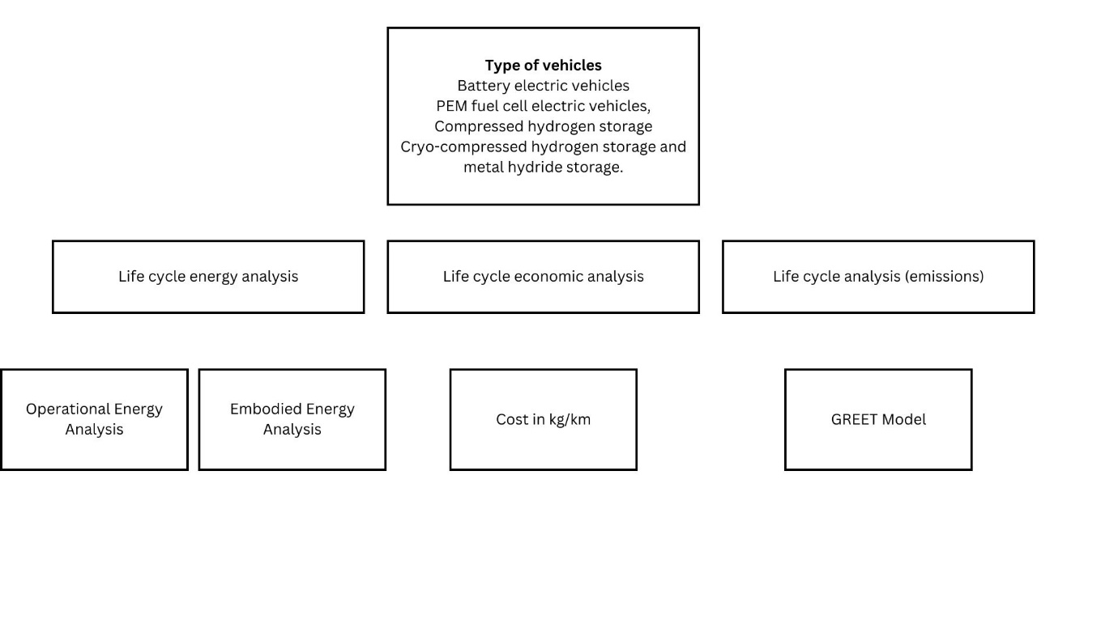

* + 1. Low Calorific Value Fuel Based Burner Design for Industrial Applications

|  |  |  |  |  |  |  |  |  |  |  |  |  |  |  |  |
| --- | --- | --- | --- | --- | --- | --- | --- | --- | --- | --- | --- | --- | --- | --- | --- |
| 31/03/2024 10:58:53 | 22m1343@iitb.ac.in | Thammina Kiran | 22M1343 | M.Tech. | 2 | Advanced Combustion and Energy Conversion Technologies | Low Calorific Value Fuel Based Burner Design for Industrial Applications | Prof. Sandeep Kumar | https://drive.google.com/open?id=1mEVEUGE4CAqdV3Vgc7Lmj4cXc8mb1jgO, https://drive.google.com/open?id=1rPqVGGAXKBexUMzDot_3LHLvPXTSnDkh, https://drive.google.com/open?id=1lUALUKhqbnONMQcvgr5iDwogFUKMPuT8, https://drive.google.com/open?id=18FdZBewv9w2Q88UBKeGUSgJKOhPZ2dov | [Abstract - Kiran Thammina.docx](https://drive.google.com/open?id=1mEVEUGE4CAqdV3Vgc7Lmj4cXc8mb1jgO) | [Graphical Abstract - Kiran Thammina.png](https://drive.google.com/open?id=1rPqVGGAXKBexUMzDot_3LHLvPXTSnDkh) | [Abstract_Final - Kiran Thammina.docx](https://drive.google.com/open?id=1lUALUKhqbnONMQcvgr5iDwogFUKMPuT8) | [Graphical Abstract_Final - Kiran Thammina.png](https://drive.google.com/open?id=18FdZBewv9w2Q88UBKeGUSgJKOhPZ2dov) | [Abstract_Final - Kiran Thammina.docx](https://drive.google.com/open?id=1lUALUKhqbnONMQcvgr5iDwogFUKMPuT8) | [Graphical Abstract_Final - Kiran Thammina.png](https://drive.google.com/open?id=18FdZBewv9w2Q88UBKeGUSgJKOhPZ2dov) |

**Keywords:** Producer gas, Flameless Combustion, Premixed Burner, CFD, Ultra-low NOx emissions

In the current global context, nations like India and China are shifting towards renewable energy sources, particularly biomass, to enhance energy security, waste management and address environmental concerns. This study focuses on the utilization of biomass-derived producer gas by biomass gasification through novel flameless combustion technology achieving ultra-low NOx emissions. By employing advanced simulation tools like ANSYS Chemkin and Computational Fluid Dynamics (CFD), the research identifies key parameters such as lean air/fuel mixtures and exhaust gas recirculation for minimizing NOx emissions (below 20 ppm). Experimental validation confirms the feasibility of flameless combustion, although adjustments are necessary for integration with existing gasifier setups. Despite initial challenges, the study underscores the potential of flameless combustion in enhancing energy efficiency and reducing environmental impact. By bridging theoretical insights, computational simulations, and experimental validation, this research contributes to the ongoing discourse on sustainable energy utilization.

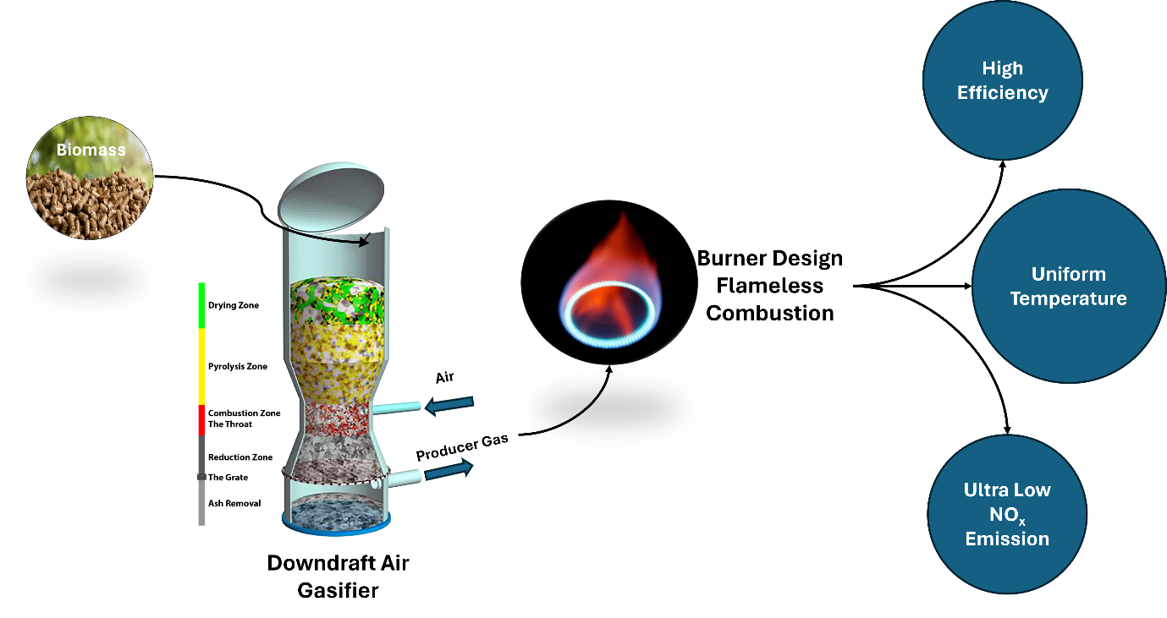

Figure 14 Representation of whole project

* + 1. Performance analysis of passive cooling design strategies for hot and dry climatic conditions.

|  |  |  |  |  |  |  |  |  |  |  |
| --- | --- | --- | --- | --- | --- | --- | --- | --- | --- | --- |
| 03/04/2024 18:10:46 | tathagatfulzele16@gmail.com | Tathagat Fulzele | 22M1370 | M.Tech. | 2 | Advanced Combustion and Energy Conversion Technologies | Performance analysis of passive cooling design strategies for hot and dry climatic conditions. | Prof. Gurubalan Annadurai | <https://drive.google.com/open?id=1cezOh2k4BmNAYOuul9ZMlvgiVIhuJh83> | [Tathagat_22m1370 - Tathagat.pdf](https://drive.google.com/open?id=1cezOh2k4BmNAYOuul9ZMlvgiVIhuJh83) |

***Keywords:*** *Green Roof, Cool Roof, Energy Savings, Thermal Comfort, Energy Efficiency, Insulation,  Urban Heat Island*

**Abstract:**

Addressing the pressing need for energy-efficient solutions amidst climate change challenges, this  study emphasizes the importance of focusing on air conditioning (AC) load management. Passive  measures such as cool roofs, green roofs, and insulation play a pivotal role in reducing AC loads by  mitigating outdoor heat infiltration into indoor spaces. Specifically tailored for hot and dry climates,  these measures have shown significant promise, with observed reductions ranging from 25% to 35%  in annual cooling loads. Furthermore, ongoing life cycle cost analysis aims to quantify the economic  viability of these measures, providing stakeholders with essential insights into their cost-effectiveness  and sustainability. Through interdisciplinary research spanning engineering, environmental science,  and economics, this study contributes to advancing energy-efficient building practices and fostering  resilient built environments.

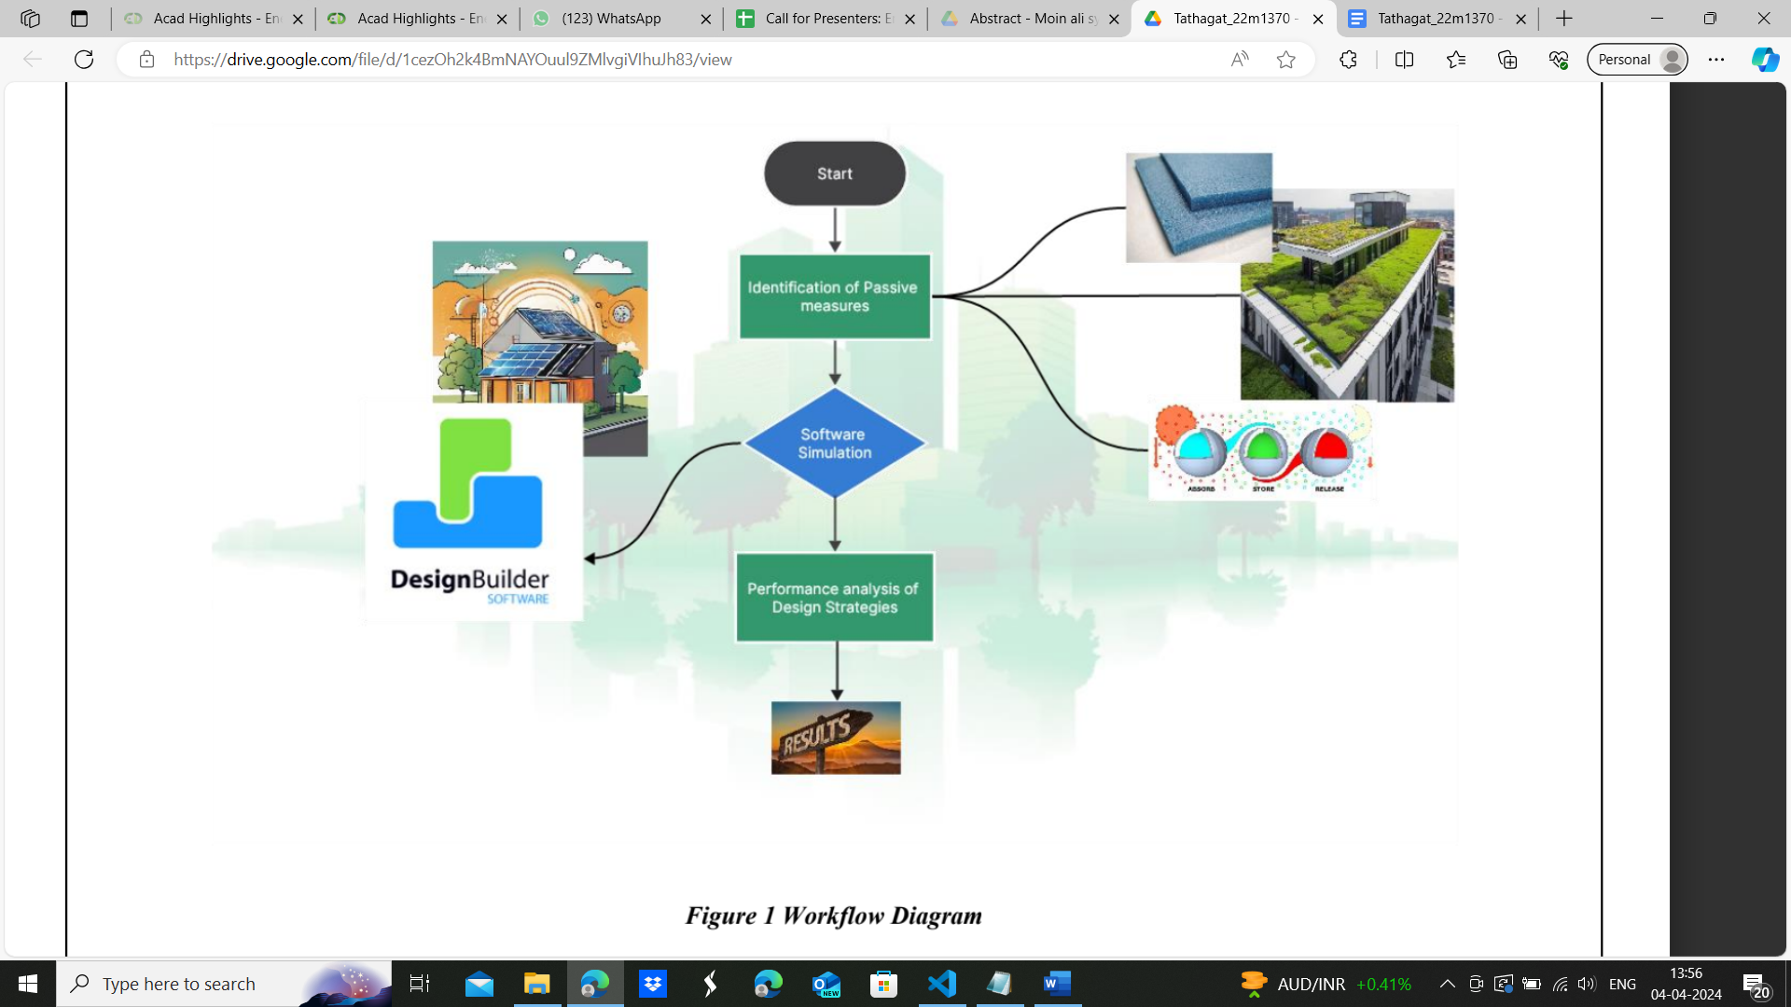

Figure 15 Workflow Diagram

* + 1. Vi. Feasibility Of Sea Water Air Conditioning For Data Center Cooling Application At Andaman And Nicobar Islands

|  |  |  |  |  |  |  |  |  |  |
| --- | --- | --- | --- | --- | --- | --- | --- | --- | --- |
| 04/04/2024 12:09:41 | moinalisyed16@gmail.com | Moin Ali Syed | 22M1352 | M.Tech. | 2 | Advanced Combustion and Energy Conversion Technologies | Feasibility Of Sea Water Air Conditioning For Data Center Cooling Application At Andaman And Nicobar Islands | Prof Gurubalan Annadurai | <https://drive.google.com/open?id=1KEn2CGU6sGDlmtibgtajMbj9cRfYIQ_w> |

**Keywords:**

Deep Sea water cooling or sea water air conditioning, Data center, Sustainability

**Abstract:**

Deep sea water cooling (DSWC) emerges as a promising solution for data center cooling in remote coastal regions like the Andaman and Nicobar Islands. This innovative cooling approach harnesses the natural thermal properties of deep sea water to efficiently dissipate heat generated by data center operations. By utilizing cold water from the ocean depths, DSWC minimizes the environmental impact of cooling systems and significantly reduces energy consumption compared to traditional air conditioning methods. In the context of the Andaman and Nicobar Islands, where traditional cooling solutions face challenges due to limited freshwater resources and high ambient temperatures, DSWC offers a sustainable and reliable alternative. This project explores the feasibility and benefits of implementing DSWC for data center cooling applications in the region. It discusses the technical aspects of DSWC systems, including seawater intake, heat exchange processes, and environmental considerations. Furthermore, it highlights the potential economic and environmental advantages of adopting DSWC technology, such as reduced operational costs, lower carbon emissions, and enhanced resilience to climate change impacts. Overall, the integration of DSWC into data center infrastructure represents a forward-thinking approach towards achieving sustainable and efficient cooling solutions in coastal areas like the Andaman and Nicobar Islands.

## Energy Storage and Conversion Technologies

* + 1. Battery thermal Management

|  |  |  |  |  |  |  |  |  |
| --- | --- | --- | --- | --- | --- | --- | --- | --- |
| 01/04/2024 17:01:36 | 22M1349@iitb.ac.in | Sumit Ashok Amale | 22M1349 | M.Tech. | 2 | Battery Thermal Management | Lalit Kumar | <https://drive.google.com/open?id=1QmHkgrVrBZXZIIddkil6vaV2EsaYyetf> |

This study delves into the thermal management of lithium-ion battery configurations,

employing a comprehensive numerical methodology to analyse different cell configurations.

The research primarily centred on understanding the thermal dynamics of lithium-ion battery

(LIB) cell operation during discharge, given that higher temperatures typically manifest during this phase. A comparison analysis was conducted for three distinct cell configurations (2, 3, and 4 cells) at varying C-rates and mass flow rates. Notably, the two-cell configuration

exhibited the most favourable results based on maximum temperature, while the four-cell

configuration demonstrated the least thermal gradient, making it optimal for thermal gradient

analysis. The study also emphasized the impact of mass flow rates on temperature and

thermal gradient, revealing that a flow rate of 0.25 m/s is efficient for cooling.

Looking ahead, future research will focus on optimizing key parameters for cell configuration,

exploring alternative cooling fluids, and delving into the design intricacies of the heat sink. The aim is to enhance battery efficiency, longevity, and safety, while also investigating the potential of alternative fluids for better thermal management. Additionally, the design and contact analysis of the heat sink with the battery cell will be explored to ensure optimal thermal conductivity and heat dissipation.

* + 1. Development of electrolyzer system for household application

|  |  |  |  |  |  |  |  |  |
| --- | --- | --- | --- | --- | --- | --- | --- | --- |
| 31/03/2024 23:41:58 | 22m1362@iitb.ac.in | Nirmal Jha | 22M1362 | M.Tech. | 2 | Development of electrolyzer system for household application | Prof. P C Ghosh | <https://drive.google.com/open?id=133P8SfKryykSuJJfLMHPR2M8GzGkeuSr> |

The world's growing concern over the environmental impact of traditional cooking fuels has triggered a search for cleaner and more sustainable alternatives. Hydrogen, as a versatile and efficient energy source, has emerged as a promising candidate for cooking fuel, offering numerous advantages over conventional fuels. Exploring the current energy scenario, particularly in India, delves into the potential of hydrogen as a substitute for traditional cooking fuels. In this study, system sizing is done based on the daily demand and then modelled in MATLAB-SIMULINK. It shows that a system with direct coupling of Solar PV and electrolyzer generated 4% less hydrogen than when connected with MPPT. There are five cooking scenarios and various lifetimes of the electrolyzer considered in this study, which shows that a system with direct coupling is economically feasible in various cases. In whole life, the proposed system can save 3.8-8.5 tonne CO2 depending on the cooking scenarios. However, none of the proposed systems was found to be economic if completely relies on firewood for cooking.

* + 1. Hydrodynamic Instability in Single Media Thermocline Storage System

|  |  |  |  |  |  |  |  |  |
| --- | --- | --- | --- | --- | --- | --- | --- | --- |
| 31/03/2024 23:32:03 | 22m1365@iitb.ac.in | Harshal Singh | 22M1365 | M.Tech. | 2 | Hydrodynamic Instability in Single Media Thermocline Storage System | Prof. Manaswita Bose | <https://drive.google.com/open?id=1WfOcGB9WxwsljnX07zSWYUIXiAKIwe-m> |

<https://drive.google.com/open?id=1J4Gr7t9QJ8gmHE2Zq0n2pX4ZxPk5--FF>

**Keywords:**

Thermal Energy Storage (TES), Thermocline, Hydrodynamic Instability, Viscous Stratification,

Thermal Disturbance

Thermal Energy Storage systems play a crucial role in mitigating the intermittent nature of renewable energy sources, particularly solar energy. Sensible single media thermocline storage tanks have emerged as a promising solution. However, studies have revealed instabilities induced by thermal disturbances, potentially impacting the performance of TES systems. This work focuses on examining hydrodynamic instability induced by thermal disturbance in single media thermocline storage tanks equipped with a porous flow distributor. Numerical simulations are conducted to investigate instability characteristics during the charging process under various operating conditions. The study delves into the interplay between TES and hydrodynamic instabilities arising from viscosity stratification within the system. A critical stability boundary, on the Atwood number and Peclet number plane, is also derived to differentiate between stable and unstable regions.

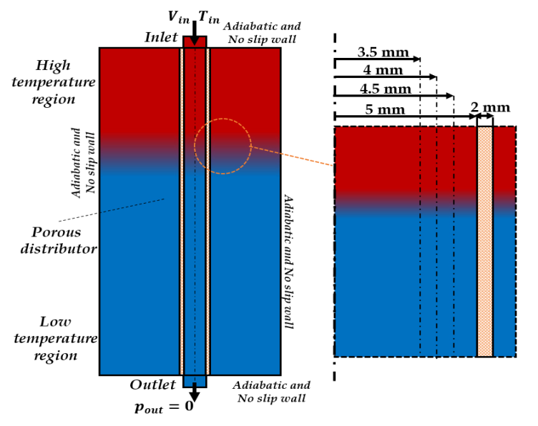

Figure 16 Schematic illustration of single media storage tank with porous ﬂow distributor - Harshal Singh

* + 1. Low-cost and high cycle life cathode for Lithium-ion batteries

|  |  |  |  |  |  |  |  |  |  |  |  |  |  |  |  |
| --- | --- | --- | --- | --- | --- | --- | --- | --- | --- | --- | --- | --- | --- | --- | --- |
| 31/03/2024 14:46:55 | a.ahuja@iitb.ac.in | Aakash Ahuja | 184176006 | Ph.D | 6 |  | Low-cost and high cycle life cathode for Lithium-ion batteries | Prof. Sagar Mitra | https://drive.google.com/open?id=1RoHaeMJzSpnRVWNJFk4ZT5AkHMUwKvvt, https://drive.google.com/open?id=1NYGW_r5AW9v6yPlxNn_1id6UcgubjOA2 | [Abstract_Aakash Ahuja_DESE - Aakash Ahuja.docx](https://drive.google.com/open?id=1RoHaeMJzSpnRVWNJFk4ZT5AkHMUwKvvt) | [Abstract Image_Aakash Ahuja_DESE - Aakash Ahuja.png](https://drive.google.com/open?id=1NYGW_r5AW9v6yPlxNn_1id6UcgubjOA2) |  |  | [Abstract_Aakash Ahuja_DESE - Aakash Ahuja.docx](https://drive.google.com/open?id=1RoHaeMJzSpnRVWNJFk4ZT5AkHMUwKvvt) | [Abstract Image_Aakash Ahuja_DESE - Aakash Ahuja.png](https://drive.google.com/open?id=1NYGW_r5AW9v6yPlxNn_1id6UcgubjOA2) |

## **Keywords:**

## Li-ion permeable robust coating; single crystal LR-LMO cathode; low-strain; lattice matching concept; manganese dissolution; high temperature study

Spinel LiMn2O4 is considered as the most promising cathode for next-generation Li-ion batteries due to its high operating voltage, environmentally-friendliness, and abundance. However, there are some challenges associated to this cathode inhibiting its practical usage are: Jahn-teller distortion followed by Mn2+ dissolution and acid corrosion under electrolyte contact which destabilises the cathode structure.

Herein, we report a novel heterostructure design; NMC layered Li-ion permeable phase grown on the Lithium-rich LiMn2O4 octahedra surface that protects the host spinel from being directly exposed to the acidic electrolyte during electrochemical cycling. In addition, it provides an efficient path for the ionic and electronic mobility resulting in improved kinetics due to its Li-ion permeability. The excess Li in LMO contributes to the structural enhancement during cycling to accommodate anisotropic volume changes, thus resulting in a robust cathode for high-voltage Li-ion batteries. The uniquely developed LiMn2O4 phase surface coated with layered structure demonstrated discharge capacity of 120 mA h g-1 at 20 ℃ temperature while retaining >97% of its initial capacity after 300 cycles at 0.5C. Further, The cathode was tested at 60 °C in half-cell format along with full cell testing against MCMB anode.

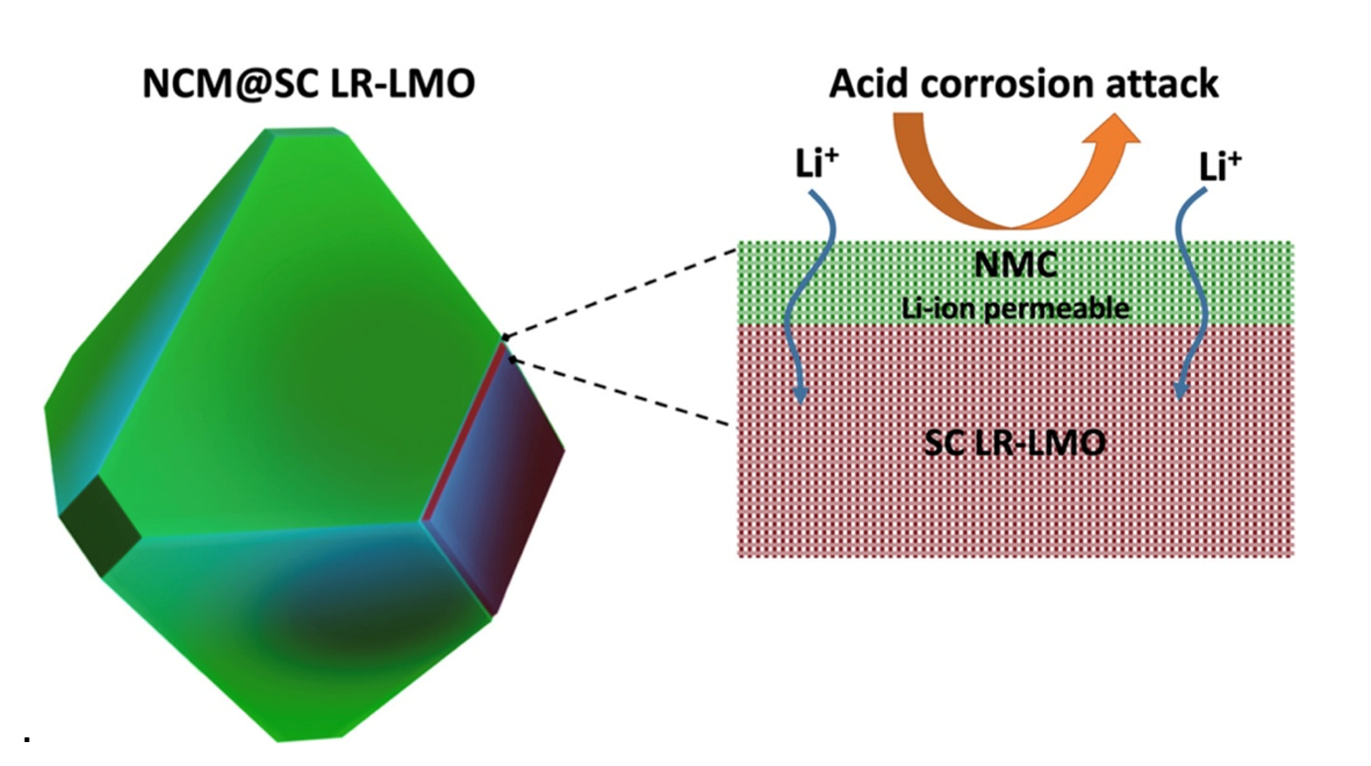

Figure 17 Schematic representing the NMC@SC-LRLMO coating

* + 1. Modelling of Reversible Solid Oxide Cells

|  |  |  |  |  |  |  |  |  |  |  |  |  |  |  |  |
| --- | --- | --- | --- | --- | --- | --- | --- | --- | --- | --- | --- | --- | --- | --- | --- |
| 31/03/2024 00:06:36 | 22m1341@iitb.ac.in | Aayush Gala | 22m1341 | M.Tech. | 2 | Energy Storage and Conversion Technologies | Modelling of Reversible Solid Oxide Cells | Dayadeep Monder | https://drive.google.com/open?id=1LCnlHu-PhOWrqANymEF4HE9JQAU5WC64, https://drive.google.com/open?id=1Ua8Bg5qLgDaDcaD0Ae2AhMIfNz7b0Han, https://drive.google.com/open?id=1J0TWe4DTCRaPvoCdiu38QIYHSCdkatXq | [Energy Day Abstract - Aayush Gala.docx](https://drive.google.com/open?id=1LCnlHu-PhOWrqANymEF4HE9JQAU5WC64) | [Resoc system_bier - Aayush Gala.jpg](https://drive.google.com/open?id=1Ua8Bg5qLgDaDcaD0Ae2AhMIfNz7b0Han) | [Energy Day Abstract - Updated - Aayush Gala.docx](https://drive.google.com/open?id=1J0TWe4DTCRaPvoCdiu38QIYHSCdkatXq) |  | [Energy Day Abstract - Updated - Aayush Gala.docx](https://drive.google.com/open?id=1J0TWe4DTCRaPvoCdiu38QIYHSCdkatXq) | [Resoc system_bier - Aayush Gala.jpg](https://drive.google.com/open?id=1Ua8Bg5qLgDaDcaD0Ae2AhMIfNz7b0Han) |

**Key Words:** Reversible solid oxide cell (ReSOC), Round-trip efficiency, Fuel Cells, Electrolysis, Thermoneutral Voltage, Cell Modelling

The integration of renewable energy sources into power grids presents significant challenges due to their intermittency and unpredictability. Addressing these challenges, large-scale energy storage and highly efficient conversion systems, such as **reversible solid oxide cells (ReSOCs)**, emerge as pivotal solutions. In fuel cell mode (SOFC), a ReSOC can utilize H2 to generate energy, while in electrolysis mode (SOEC), it consumes energy to produce H2. The round-trip efficiency of such a system is of prime interest, which can be enhanced by reducing temperature or increasing pressure. Moreover, ReSOCs offer the advantage of utilizing carbonaceous fuels such as reformed methane and syngas, further improving round-trip efficiencies.

To accurately predict ReSOC performance, a fast and **efficient quasi-2-D cell model** has been developed **using Python**. This model can simulate both modes of operation and predict local variations of cell variables. It can incorporate both humidified hydrogen and carbonaceous gases as fuels, providing insights into performance under both isothermal and non-isothermal conditions. This predictive capability is invaluable for designing and optimizing ReSOC systems for real-world applications.

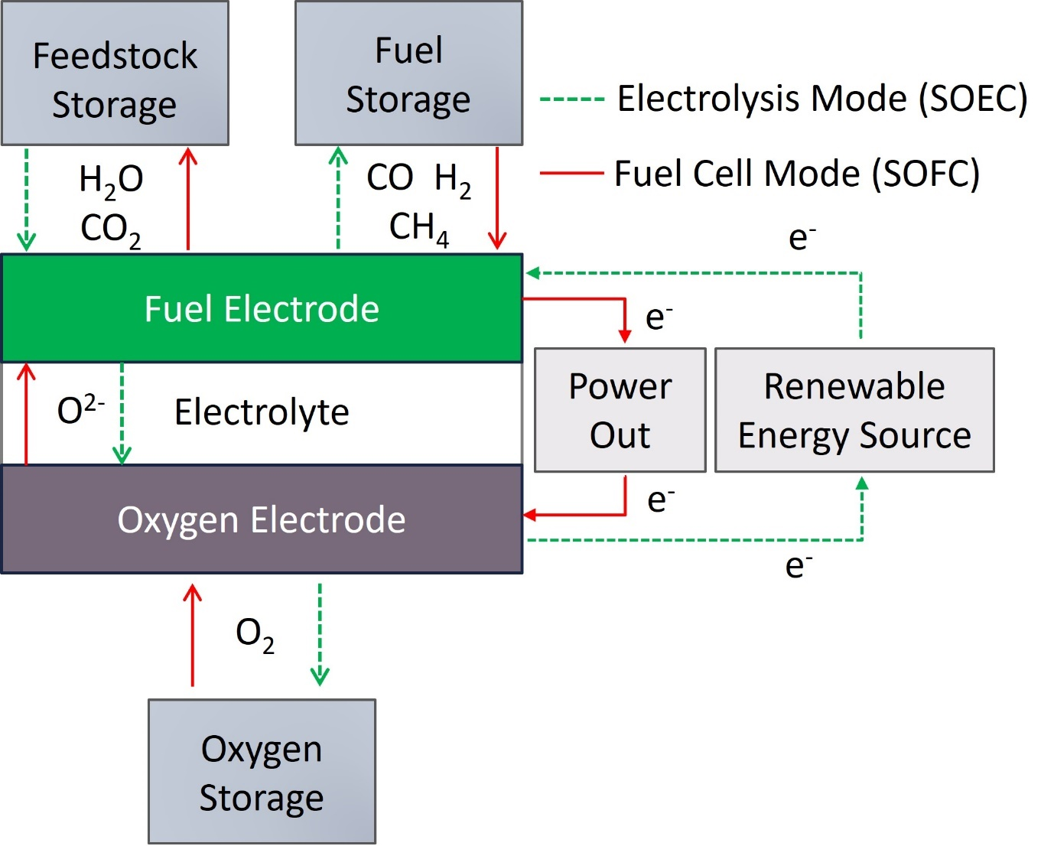

Figure 18 A Schematic of a Reversible Solid Oxide Cell (ReSOC) System

* + 1. Battery Thermal Management: Generalized Thermal Modelling via ECM Approach

|  |  |  |  |  |  |  |  |  |  |  |  |  |  |  |  |
| --- | --- | --- | --- | --- | --- | --- | --- | --- | --- | --- | --- | --- | --- | --- | --- |
| 30/03/2024 19:21:42 | 22m1346@iitb.ac.in | Devarshi Pathak | 22M1346 | M.Tech. | 2 | Energy Storage and Conversion Technologies | Battery Thermal Management: Generalized Thermal Modelling via ECM Approach | Prof. Sandeep Kumar | https://drive.google.com/open?id=1eh_2nNGoQ7LsK2QzYEfPdeic3O0WK7sv, https://drive.google.com/open?id=1OtWdxjQ-NaCRWa8GVrEQOoowNqt-A7dh | [Abstract - 22M1346 - Devarshi Jayantkumar Pathak.docx](https://drive.google.com/open?id=1OtWdxjQ-NaCRWa8GVrEQOoowNqt-A7dh) | [Block Diagram - 22M1346 - Devarshi Jayantkumar Pathak.png](https://drive.google.com/open?id=1eh_2nNGoQ7LsK2QzYEfPdeic3O0WK7sv) |  |  | [Abstract - 22M1346 - Devarshi Jayantkumar Pathak.docx](https://drive.google.com/open?id=1OtWdxjQ-NaCRWa8GVrEQOoowNqt-A7dh) | [Block Diagram - 22M1346 - Devarshi Jayantkumar Pathak.png](https://drive.google.com/open?id=1eh_2nNGoQ7LsK2QzYEfPdeic3O0WK7sv) |

Keywords: Battery Thermal Management, Equivalent Circuit Model, Heat Generation rate, CFD analysis

The transition from fossil-based fuels to renewables, including the EV sector, highlights the significance of batteries. Thermal issues underscore the critical importance of Battery Thermal Management Systems (BTMS) for ensuring battery safety and performance. This Master's project proposes a generalized methodology for developing an Equivalent Circuit Model (ECM) to replicate battery heat generation rates, expediting BTMS development for emerging battery chemistries. Feasibility assessments of equivalent circuits across various battery chemistries from literature led to the selection of the 2-RC-Thévenin model for the ECM approach. PLECS software was utilized to assess component dependency on heat generation rates, while CFD simulations evaluated thermal severity across different cell geometries. Experimental procedures involving Electrochemical Impedance Spectroscopy (EIS) and Open Circuit Voltage (OCV) tests are designed to determine internal resistance and the Entropy coefficient, respectively in order to calculate total heat generation rate. The cylindrical 18650 cell for NMC and LCO are selected for the experimentation. Validation of the thermal performance of the ECM-based circuit against actual battery cells at specific C-rates constitutes the final step. This research facilitates rapid prototyping and optimization of BTMS, crucial for advancing novel battery technologies.

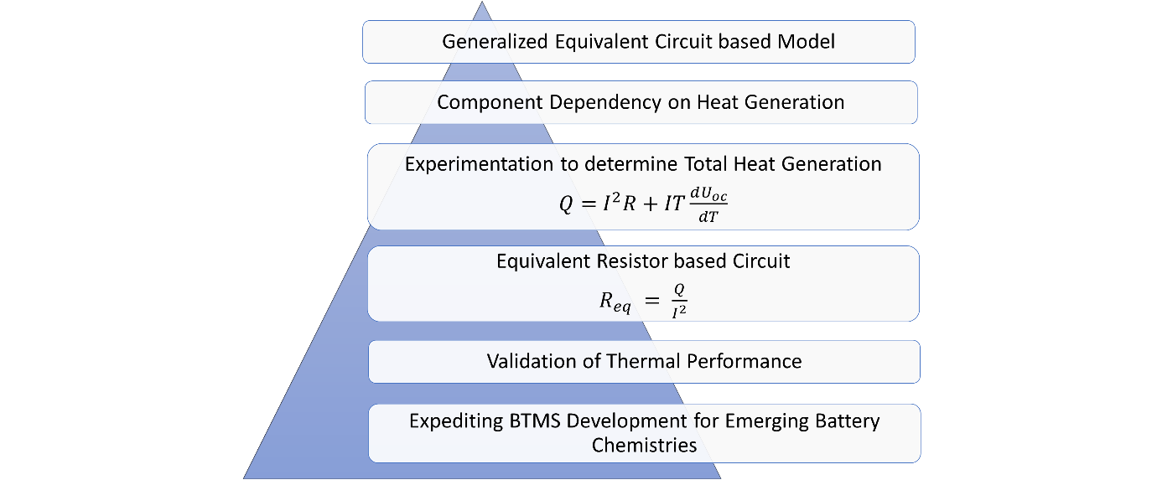

Figure 19 Masters' Thesis Project: Workflow

* + 1. Enhancing Sodium Sulfur Batteries with 3D Current Collectors and Sulfur Hosts

|  |  |  |  |  |  |  |  |  |  |  |  |  |  |  |
| --- | --- | --- | --- | --- | --- | --- | --- | --- | --- | --- | --- | --- | --- | --- |
| 30/03/2024 18:52:51 | ritikawawge5400@gmail.com | Ritika Wawge | 22M1367 | M.Tech. | 2 | Energy Storage and Conversion Technologies | Enhancing Sodium Sulfur Batteries with 3D Current Collectors and Sulfur Hosts | Prof. Sagar Mitra | https://drive.google.com/open?id=1Rq-XMsmHNI_1jFyGB5P5pV4J-YUo4ef4 | [Energy Day Abstract - Ritika Wawge.docx](https://drive.google.com/open?id=1Rq-XMsmHNI_1jFyGB5P5pV4J-YUo4ef4) |  |  |  | [Energy Day Abstract - Ritika Wawge.docx](https://drive.google.com/open?id=1Rq-XMsmHNI_1jFyGB5P5pV4J-YUo4ef4) |

**Keywords:**

Polyaniline-coated carbon cloth, Sulfur host, Cycle life, Free standing cathode, Catholyte

This research delves into the recent advancements in room temperature sodium-sulfur (Na-S) batteries, aiming to overcome key challenges hindering their practical use. Focusing on enhancing performance and scalability, novel approaches like 3D current collector architectures and efficient sulfur host designs are explored. The study underscores the significance of materials with high electrical conductivity and flexibility, with nitrogen doping playing a crucial role. Innovative designs such as double-carbon-shell architectures and catalytic sulfur hosts are investigated for their potential in addressing battery-related issues. Additionally, the introduction of a groundbreaking 3D current collector, MGF, is highlighted for its promising benefits in energy density and stability. The research also examines the deposition of Ni3Sn4 intermetallic alloys on various substrates, showcasing their remarkable discharge capacity and cycle performance. Moreover, the utilization of polyaniline-coated carbon cloth as a 3D current collector is discussed, offering improved energy storage capabilities due to its high specific capacitance and binder less assembly strategy. These findings collectively signify significant progress toward achieving efficient and sustainable energy storage solutions, propelling us towards a greener future.

* + 1. Thermal Management of High Energy Density Batteries

|  |  |  |  |  |  |  |  |  |  |  |  |  |  |  |
| --- | --- | --- | --- | --- | --- | --- | --- | --- | --- | --- | --- | --- | --- | --- |
| 21/03/2024 11:22:05 | ekta.shrinet@iitb.ac.in | Ekta Singh Shrinet | 194170007 | Ph.D | 5 | Energy Storage and Conversion Technologies | Thermal Management of High Energy Density Batteries | Prof. Lalit Kumar | https://drive.google.com/open?id=1uZjssaKj5YxM1y0_LjxZd6QLMNnWAna1 | [Abstract_Ekta - Ekta Singh Shrinet.docx](https://drive.google.com/open?id=1uZjssaKj5YxM1y0_LjxZd6QLMNnWAna1) |  |  |  | [Abstract_Ekta - Ekta Singh Shrinet.docx](https://drive.google.com/open?id=1uZjssaKj5YxM1y0_LjxZd6QLMNnWAna1) |

**Keywords:**

Battery Thermal Management System, Li-ion Battery, Liquid Cooling, Electric Vehicle(EV), Variable Contact Area

The role of Li-ion batteries in vehicle electrification is significant, owing to their long lifespan, high energy density, and low self-discharge rates. These advantages make Li-ion batteries a preferred choice for electric vehicles (EVs). However, to ensure optimal operation, certain conditions must be met, such as maintaining a maximum temperature limit of 40°C and a maximum temperature difference limit of 5°C. To maintain these temperature conditions, proper cooling of the battery module is essential. While increasing the flow rate of the coolant can help regulate the maximum temperature of the battery, achieving thermal uniformity across the module presents a challenge. To address this issue, a unique relationship between the contact area of the battery and coolant is proposed in the study.

This relationship involves increasing the contact area in the direction of flow to ensure uniform heat transfer from all batteries. Aluminum strip between battery and the coolant channel is introduced for providing the varying contact area. The study compares the effectiveness of straight and serpentine coolant flow channels. Results show a 74% improvement in thermal uniformity with straight channels and a 71.7% improvement with serpentine channels.

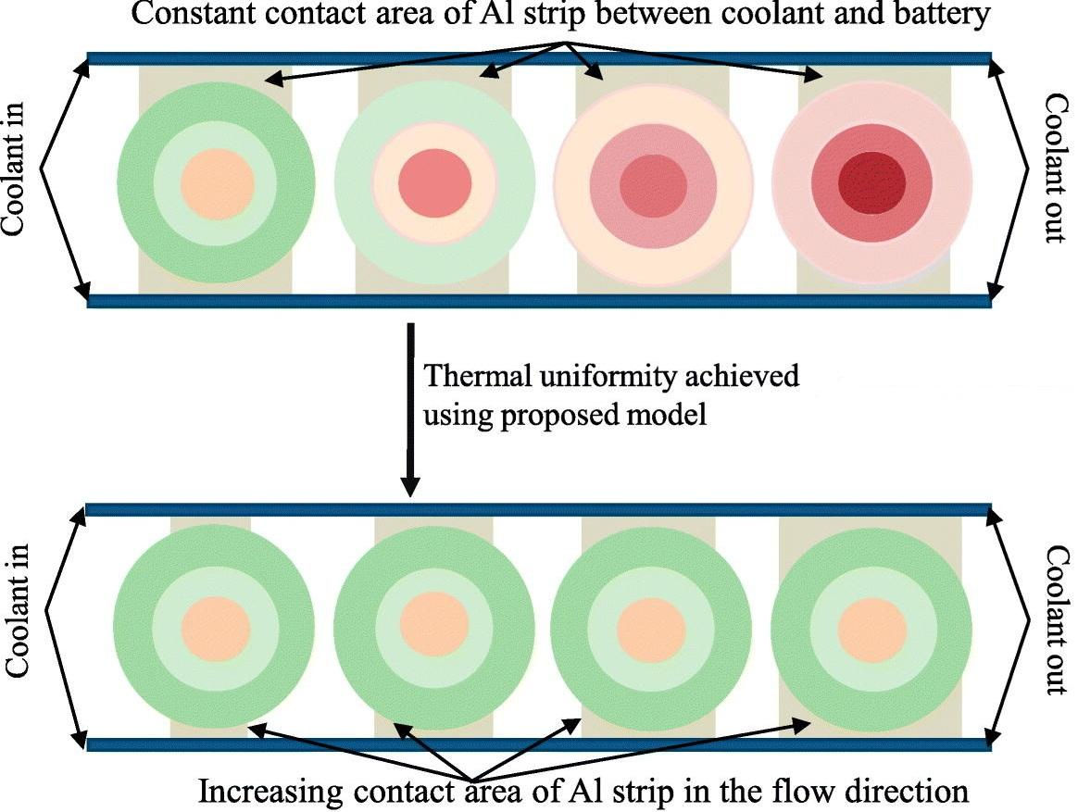

Figure 20 Constant contact area and increasing contact area temperature contour

xi. Effect of NaI on the morphology, composition and thickness of Al-Mg electrodeposits from molten salts

|  |  |  |  |  |  |  |  |  |
| --- | --- | --- | --- | --- | --- | --- | --- | --- |
| 04/04/2024 19:01:23 | 204176002@iitb.ac.in | B Sreesvarna | 204176002 | Ph.D | 4 | Effect of NaI on the morphology, composition and thickness of Al-Mg electrodeposits from molten salts | Sankara Sarma V Tatiparti | <https://drive.google.com/open?id=187OHbJEIVOxSVtAOTR7_70zoQvT_1qJG> |

**Keywords:**

Al-Mg alloys, Morphology, Alloy composition

**Abstract:**

Aluminium (Al) – Magnesium (Mg) alloys are key materials for several industrial applications such as the automotive industry, aviation, household applications, and heat exchangers because of their lightweight, mechanical and chemical properties, corrosion resistance, and aesthetics. Electrodeposition is the most versatile method for the preparation of Al-Mg films due to the reduced thermal stress on the core material, time, and economic feasibility. Electrodeposition also has the advantage of the controllable thickness of Al-films deposited and continuous uniform film deposition.

The Al-Mg alloy electrodeposition reported previously aimed at depositing powders and dendrites of Al-Mg with a higher percentage of Mg. The current work electrodeposition of Al-Mg alloys was deposited using chloride-based molten salt electrolyte system. A maximum of 3.50 wt. % of Mg was achieved using this electrolyte. To improve the morphology and Mg content in the deposit, an additive NaI was used.  Addition of 2 % NaI was found to improve the conductivity of the electrolyte. Hence, it offered a wider range of current densities when compared to electrolyte without NaI for galvanostatic depositions. The use of NaI was found to improve the deposit morphology, composition and thickness